Laura Docherty
GPS Admin Guide V1.1


Admin Guide
Grants Processing System

Version | Date | Author | Changes
V1.0 | 30/1/16 | Laura Docherty | First finalised version
V1.1 | 2/2/16 | Laura Docherty | Version Control Table Implemented
V1.1 | 2/2/16 | Laura Docherty | Additional overview detail added to section How to Run Finance Round Report for Sage Export
V1.1 | 2/2/16 | Laura Docherty | Added section How to Run Claims Report for Sage Export

Contents
GPS Admin Dashboard 5
Using the System 6
Users 6
Understanding the All Users Dashboard 6
Add a new user 7
User Registration 7
Invite a User to GPS 7
Amend a user details 7
Resend email confirmation 8
Reset User Password 8
Lock a User Account 9
Groups 10
Understanding the Groups Dashboard 10
Default Groups 10
Add a user to group membership 10
Remove a user from group membership 11
Funds 12
Understanding the Funds Dashboard 12
Creating a New Fund 12
Edit an Existing Fund 13
Create an Eligibility Form for a Fund 14
Create Assessment Form 15
Edit an Overview Assessment Form 15
Create an Approval Form 16
Create a Decision Form 17
Create a Project Report Form 18
Create an End of Project Report 18
Rounds 19
Understanding the Rounds Dashboard 19
Creating a New Round 20
Managing a Current Round 20
Reopen a Round 21
Creating a Board Report 22
Publishing Results of a Round 22
Edit Round Properties 22
How to Run Finance Round Report for Sage Export 23
Grants 23
Understanding the Grants Dashboard 24
Grid Mode 24
Complete a Grant/Project 25
Assessments 26
Understanding the Assessments Dashboard 26
Starting the Eligibility Check for a Submitted Grant 27
Starting the Initial Assessment Check for a Submitted Grant 29
Starting the Overview Assessment for a Submitted Grant 33
Confirm the Assessment Decision for a Submitted Grant 35
Awards 37
Understanding the Awards Dashboard 37
Allocating an Award to a submitted grant 37
Projects 40
Claims 41
Project Reports 41
End of Project Reports 41
Organisations 41
Understanding the All Organisation Dashboard 42
Creating a New Organisation 42
Edit an Existing Organisation 42
Museums 43
Understanding the All Museums Dashboard 43
Creating a New Museum 43
Edit an Existing Museum 44
Delete an Existing Museum 44
Keywords 45
Understanding the Keywords Dashboard 45
Create a new Keyword 45
Edit a Keyword 45
Delete a keyword 46
Aims 46
Understanding the Aims Dashboard 46
Creating a New Aim 47
Edit an existing Aim 47
National Strategy 48
Understanding the National Strategy Dashboard 48
Creating a New National Strategy Objectives 49
Edit an existing National Strategy Objectives 49
Archive an existing National Strategy Objectives 49
Recognition 50
Understanding the Recognition Objectives Dashboard 50
Creating a New Recognition Objective 50
Edit an Existing Recognition Objective 50
Archive an existing Recognition Objectives 51
Slippage 51
Understanding the System Flow 53
Account Creation 53
Create A Funding Round 53
Starting the Assessment Process 53
Starting the Award Process 54

GPS Admin Dashboard

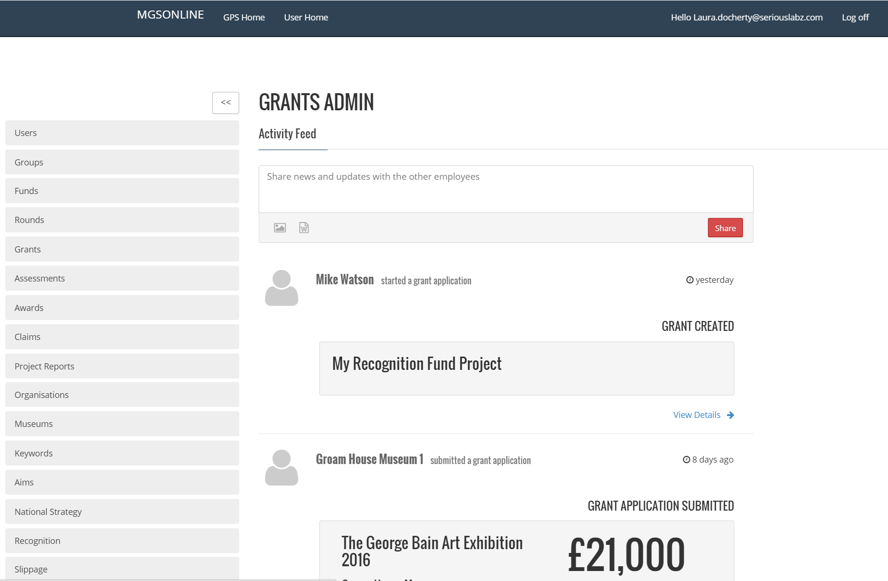

Using the System

Users
The people on your team each need a user account before they can sign in and access the GPS.
GPS user administration can be accessed by clicking on the Users section with the GPS Admin Dashboard. All GPS Users are accessed through the User Section.
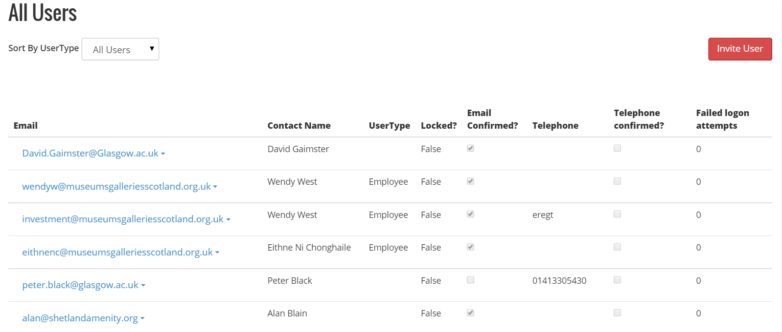

Understanding the All Users Dashboard
Within the All Users panel there are a number of columns:
Email | This is the email address that was used to sign up for GPS Online
Contact Name | This is the display name that was used to sign up for GPS Online
User Type | If a user has signed up for the service without being invited they will not have a UserType however if they are invited to the service by a GPS Admin they will have assigned a UserType e.g. Employee
Locked? | This has a value to True or False. False means the user can sign in. A value of true means the user cannot sign in.
Email Confirmed? | This value shows whether the user has validated their email account by completing the registration process. If this box is not ticked the user hasn’t completed the registration process by clicking on the email message they should have received with the subject “Confirm your MGSOnline account”. If they do not complete the registration process they will be unable to log in
Telephone | Telephone number for the user
Telephone Confirmed? | This value can be true or false. The default of false means that an MGS Admin hasn’t validated the telephone number. The value can be set to true if a MGS Admin was able to validate the number
Failed Login Attempts | The system tracks the number of failed logon attempts a user has had. A high number may suggest a brute force attack of that user account

Add a new user
There are two ways to add new users to the GPS.

User Registration
- Using the browser (e.g. Internet Explorer, Chrome) visit mgs-online.org.uk
- Click Register
- Complete the “Register for MGSOnline” form
- Click Register
- Once the registration form has been completed you will be presented with the following message
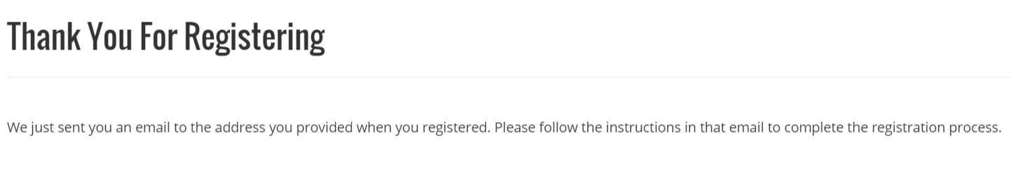
- Check your email account for an email message with the subject “Confirm your MGSOnline account”
Important
If the email does not appear in your inbox within 10-15 minutes please check your spam or junk mail folder. If the message has arrived in the spam or junk mail folder move the email to your inbox to allow the functionality of the message to operate correctly
- Open the email and Click the link contained to complete the registration process

Invite a User to GPS
- Click on the Users section within the GPS Admin Panel
- Click on the Invite User button
- Complete the Invite a user to this site form shown below
Select the correct User type i.e. customer, employee etc

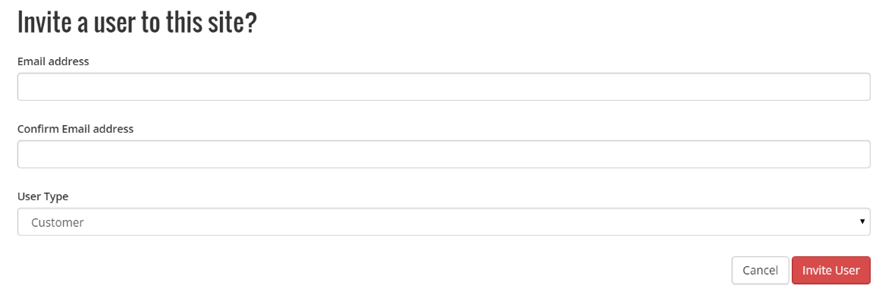
- Click Invite User
- The new user will then receive an email to follow through the registration process

Amend a user details
- Click on the drop down arrow on the user you wish to amend
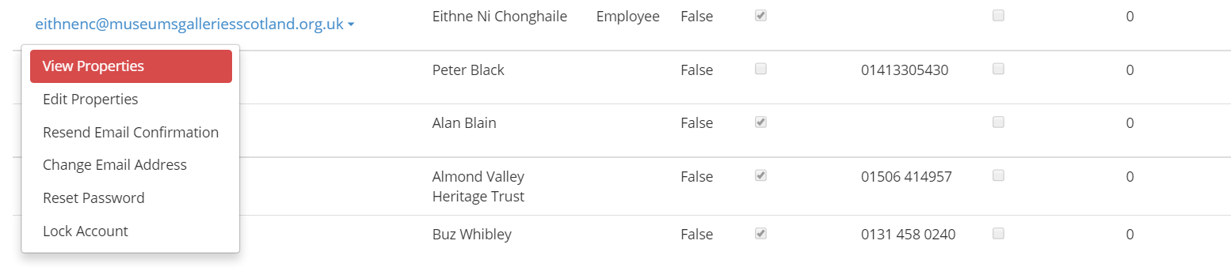
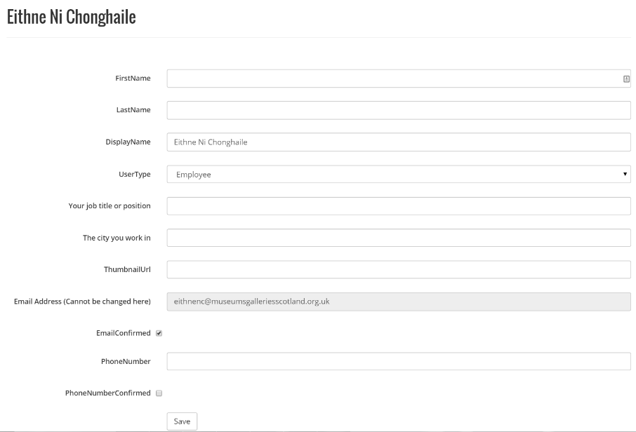
- Click Edit Properties

- When finished click Save

Resend email confirmation
There may be times that a user hasn’t received the email to confirm their email address and complete the registration process. This could happen for numerous reasons eg:-
- Incorrect spelling of email address (GPS admin can resolve that by editing the properties of the user)
- Quarantined email
- User mailbox not receiving mail due to mailbox storage limits exceeded

- Click on the drop down arrow on the relevant user
- Click on Resend Email Confirmation

- Click Resend Email Confirmation
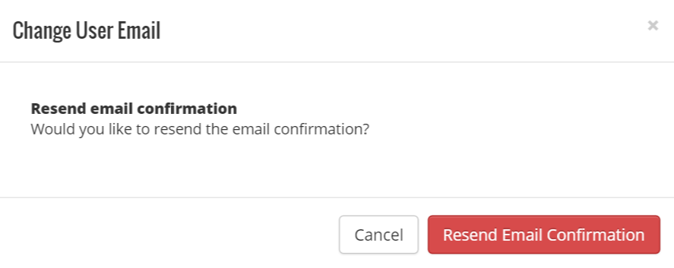

Reset User Password
- Click on the drop down arrow on the relevant user
- Click Reset Password

- Click Reset Password

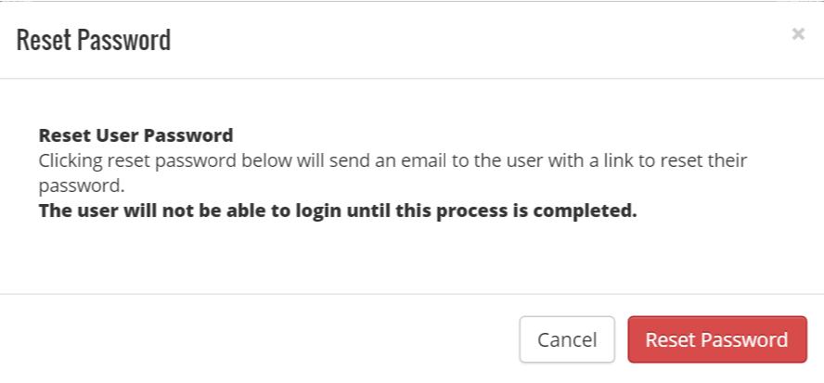

Lock a User Account
- Click on the drop down arrow on the relevant user
- Click on Lock Account

Important
After you click on Lock Account the User will not be able to login until this account has been unlocked by a GPS Admin

- Click on Lock Account

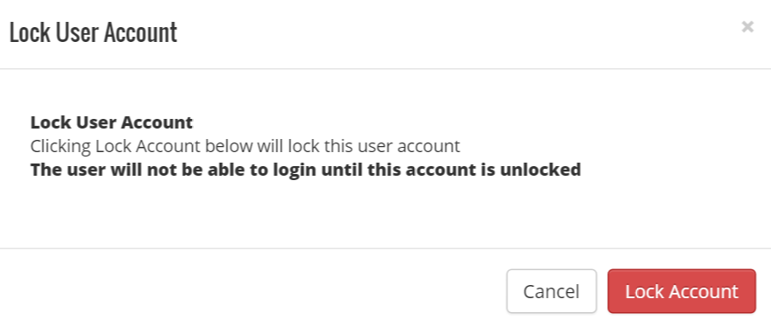

[Grab your reader’s attention with a great quote from the document or use this space to emphasize a key point. To place this text box anywhere on the page, just drag it.]

Groups

Understanding the Groups Dashboard
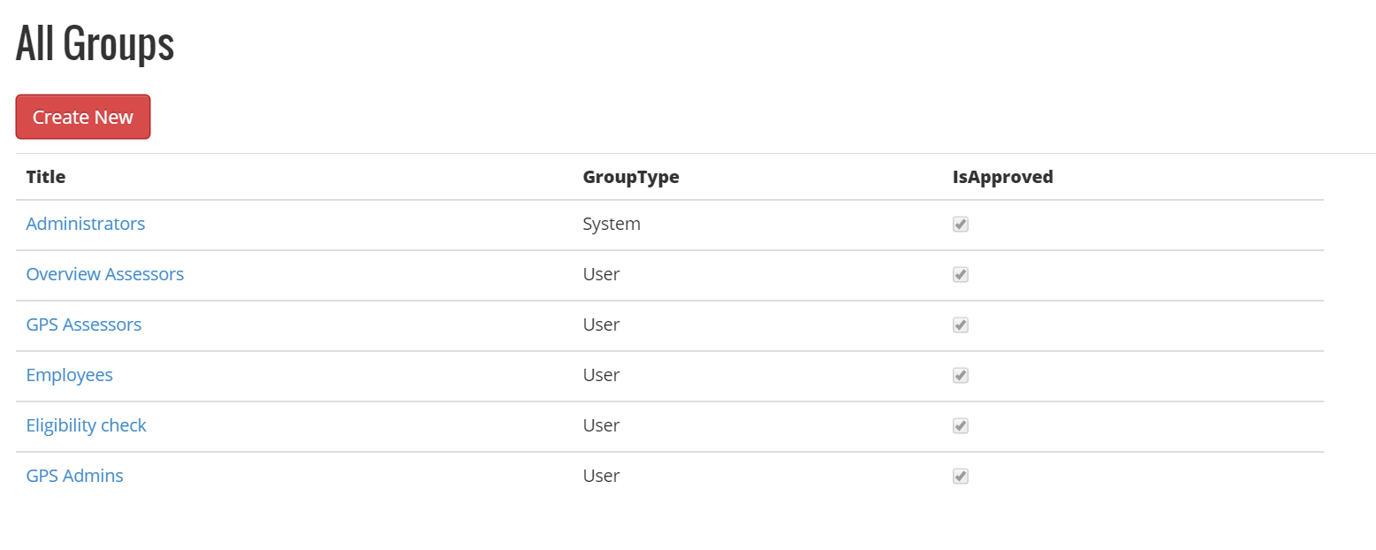
Within the All Groups dashboard there are a number of columns:
Email | This is the email address that was used to sign up for GPS Online
Title | This is the name of the Group
Group Type | The type of group
Is Approved | Whether the group is an approved active group

Default Groups
There are 6 default groups that have been configured for GPS
Administrators | This group is for administration of the full grants processing system and is currently used by the vendor and not MGS
Overview Assessors | This group is for users that will conduct overview assessments within the system. If a required overview assessor is not in this group they will not be able to carry out their role.
GPS Assessors | This group is for users that will conduct gps assessments within the system. If a required gps assessor is not in this group they will not be able to carry out their role.
Employees | This group is for MGS employees that will be using the system
Eligibility Check | This group is for users that will conduct gps application eligibility checks.
GPS Admins | This group is for users that will be providing GPS Administration.

Add a user to group membership
- Click on the title of the group you require to amend
- Click add member
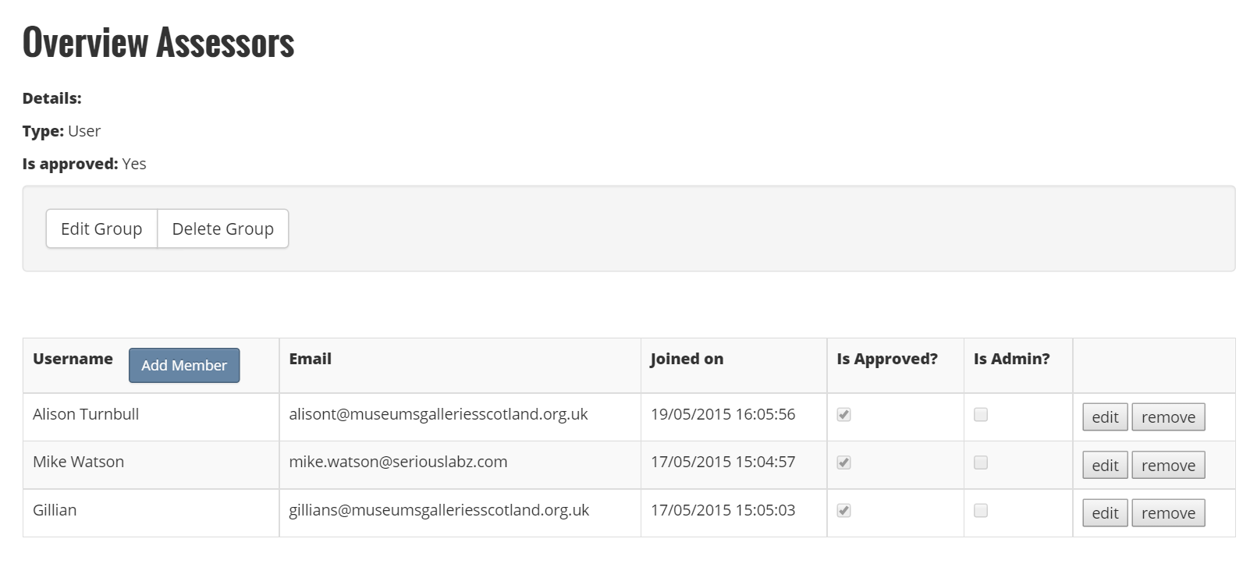
- Select the user from the drop down list of User Names
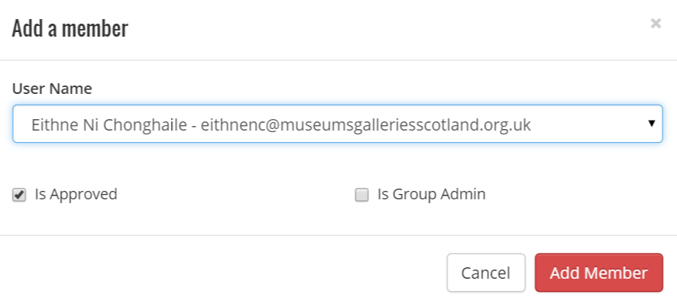
- Click Add Member

Remove a user from group membership
- Click on the title of the group you require to amend
- Find the user that membership needs to be removed from and click remove
- Click Remove Member
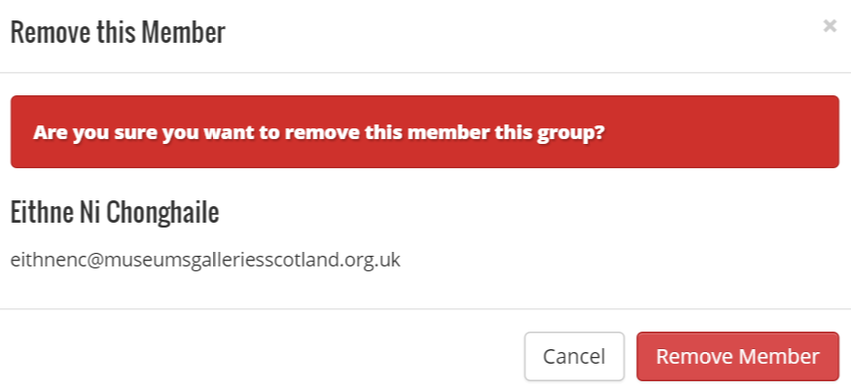

Funds

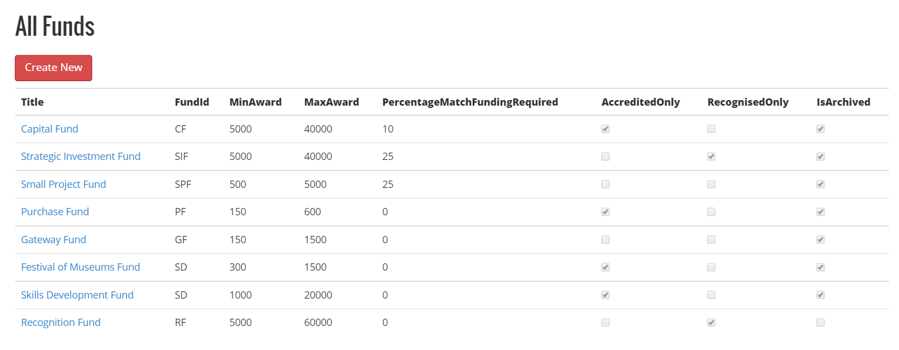

Understanding the Funds Dashboard
Within the All Funds dashboard there are a number of columns:
Title | Name of the Fund
FundID | Unique ID to identify the Fund. Note: The fund ID once the fund has been used as the unique ID is used throughout the process.
Min Award | The minimum amount an application can apply for
Max Award | The maximum amount an application can apply for
PercentageMaxFundingRequired | How much funding the applicant must get from other bodies
Accredited Only | States whether a fund can be applied for by accredited museums only
Recognised Only | States whether a fund can be applied if the application has recognised collection only
Is archived | This toggles between the fund being available to applicants

Creating a New Fund
- Click Create New in the All Funds Dashboard
- Use a Title that is easily identifiable for the applicant and MGS Admins e.g. Capital Fund
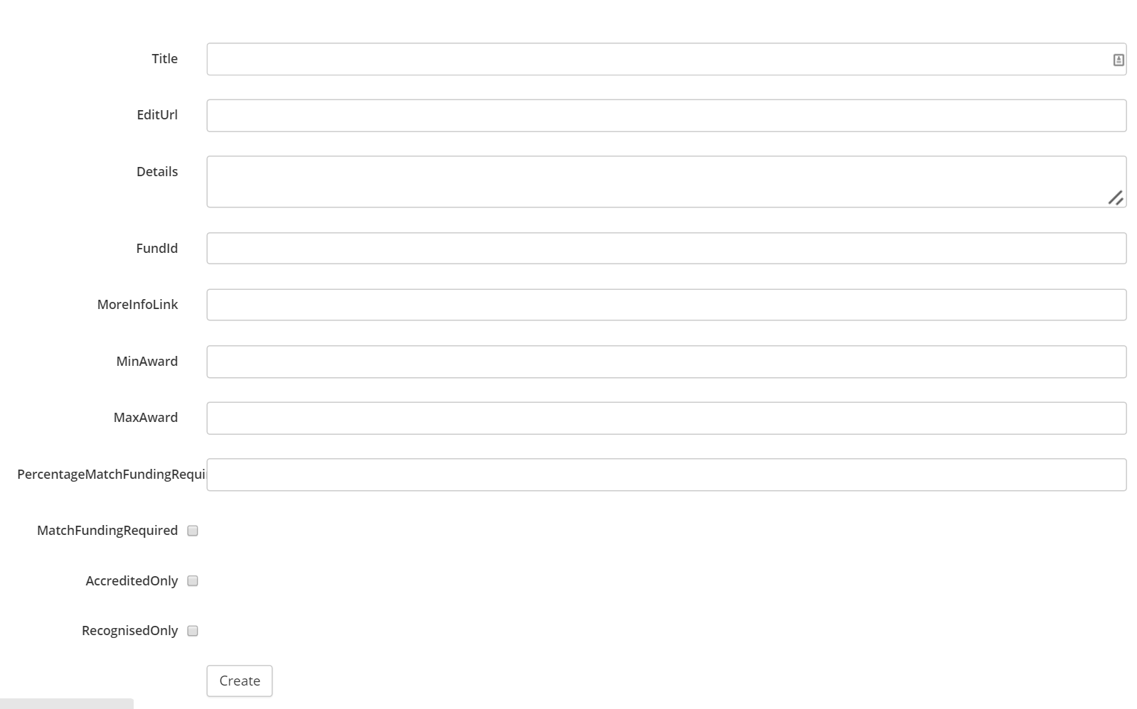
- EditUrl should contain /Funds/”title(no spaces)” e.g. /Funds/CapitalFund
- Details should contain a brief explanation of the fund
- FundID should be unique and typically 2 to 3 characters i.e. CF
- MoreInfoLink should contain the url that contains more info on the MGS public website e.g. http://www.museumsgalleriesscotland.org.uk/funding/capital-fund/
- MinAward is the minimum amount the applicant can apply for
- MaxAward in the maximum amount the applicant can apply for
- PercentageMatchFundingRequired should be how much funding the applicant must get from other bodies
- MatchFundingREquired should be ticked if the applicants require to match funding
- AccreditedOnly should be ticked if the applicants require to be accredited
- RecognisedOnly should be ticked if the applicants require a recognised collection
- Click Create

Edit an Existing Fund
- Click the Title of the Fund in All Funds
- Click Edit


- Edit the fields that require amending
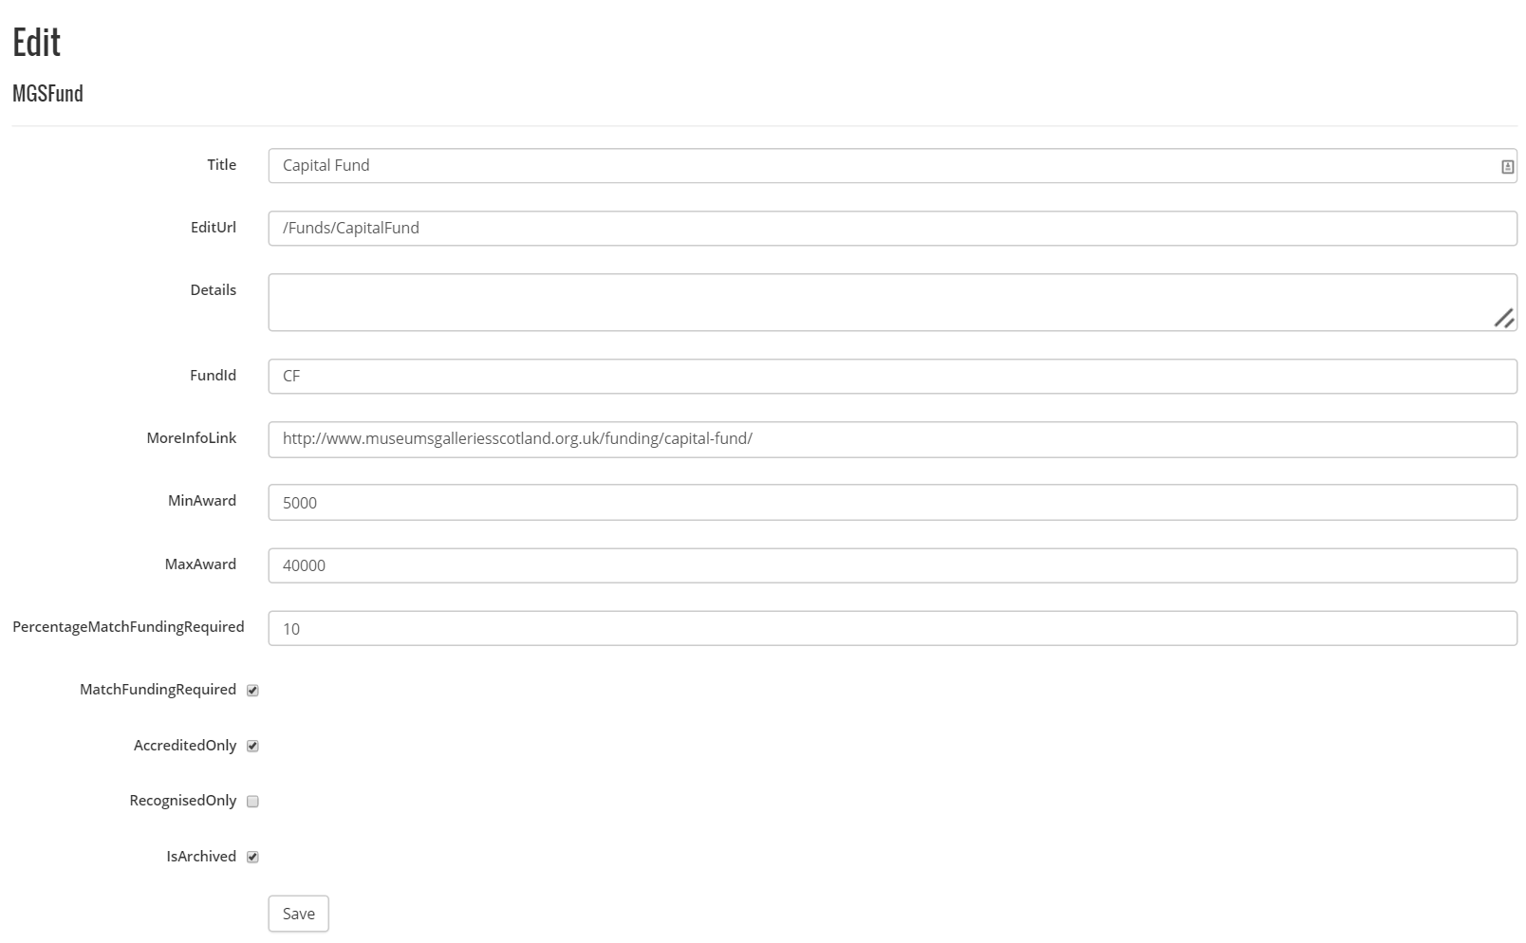
- Click Save

Create an Eligibility Form for a Fund
- Click on the Title of the Fund you the eligibility form for
- In Forms Section under Assessment click on Eligibility Form
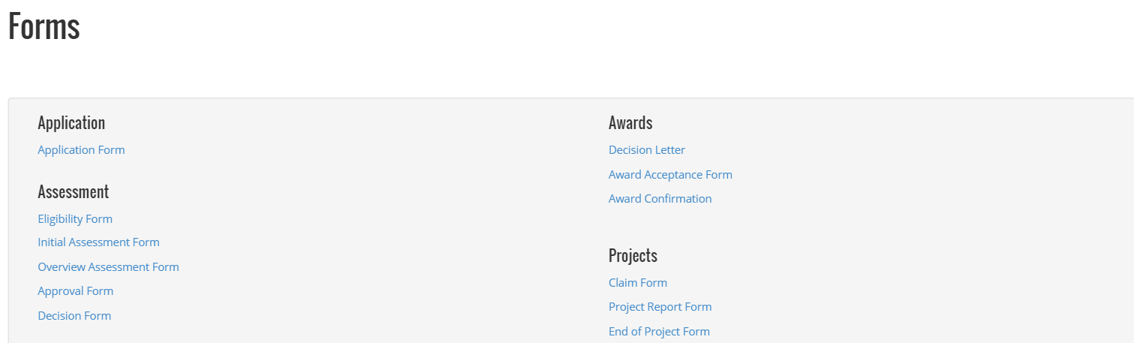
- The suggested title of the form is eligibility form and typically unless you want to change that name you should type eligibility form
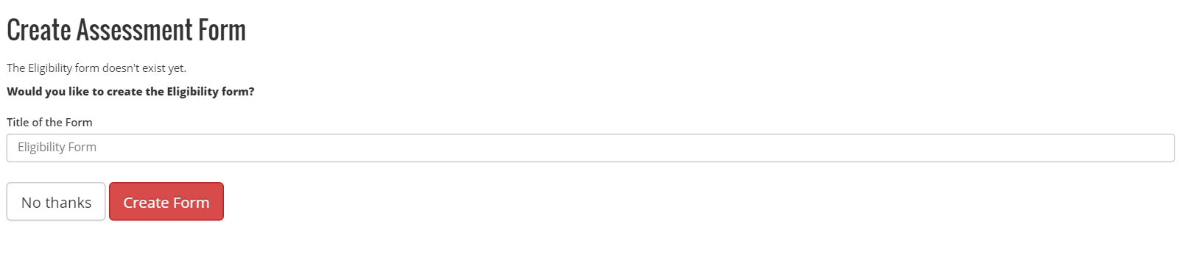
- Click Create Form
- If you want to add additional fields these are in addition to the mandatory fields. The mandatory fields should not be changed
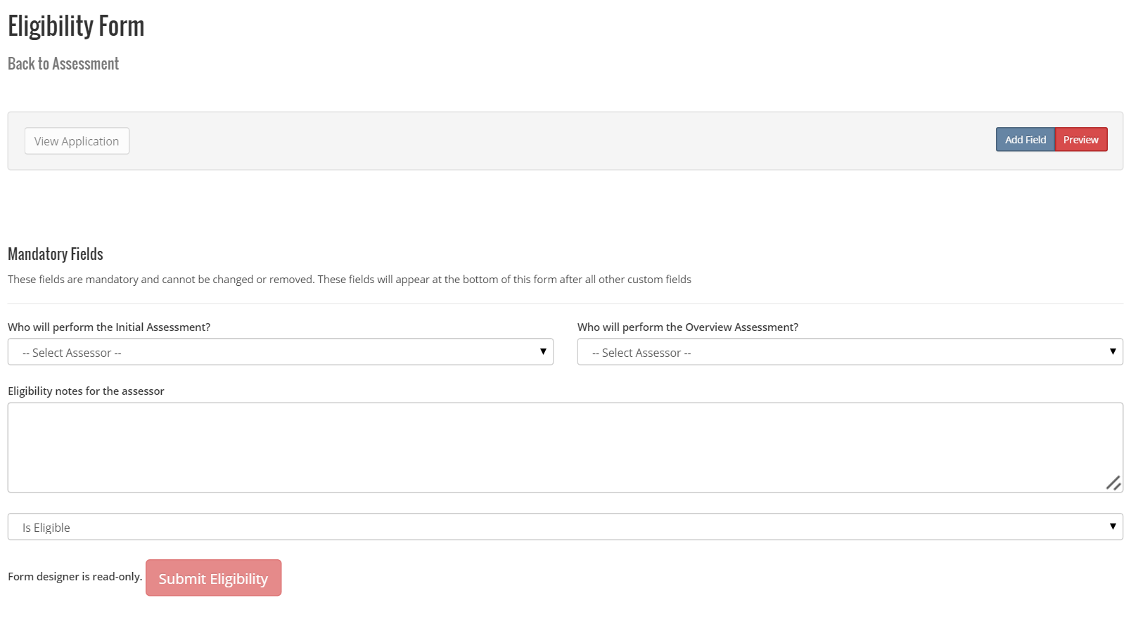

Create Assessment Form
- Click on the Title of the Fund you want to create the assessment form
- In Forms Section under Assessment click on Assessment Form
- The suggested title of the form is initial form and typically unless you want to change that name you should type initial form
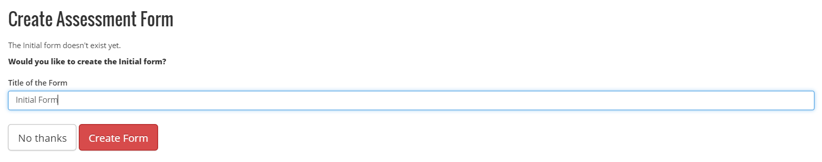
- Click Create Form
- The initial assessment form is created and you now have to add in any criteria for the assessment process
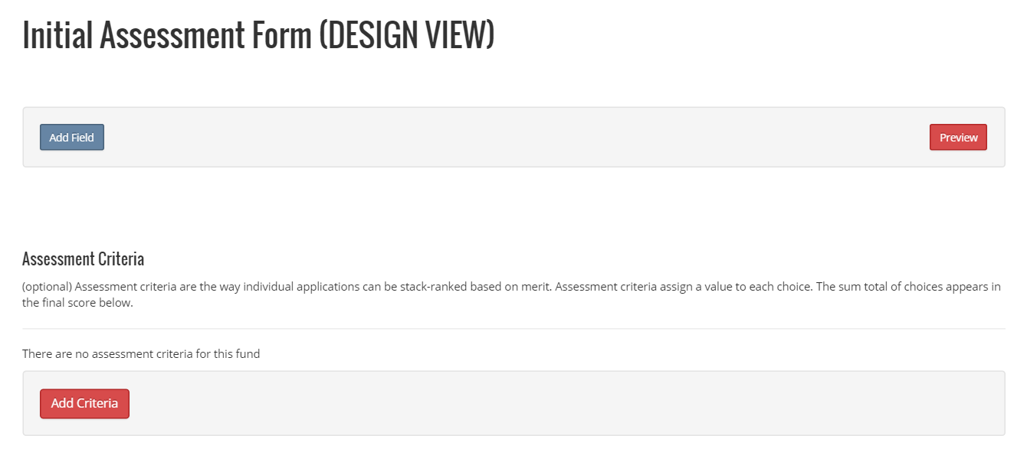
- Click Add Criteria
- Type in the values for the required criteria
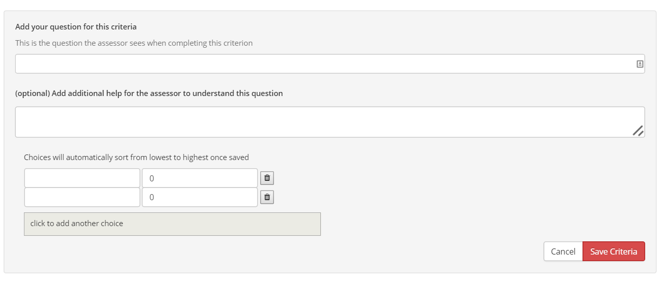
- Click Save Criteria
- Repeat step 6 through 8 for as many criteria required

Edit an Overview Assessment Form
The overview assessment form doesn’t require to be created as the over viewer is essentially overviewing the initial assessment and it uses the same form. There may be times that there is a requirement for the over viewer to track additional information and additional fields can be added if that is the case.
- Click on the Title of the Fund you want to amend the overview assessment form
- In Forms Section under Assessments click on Overview Assessment Form
- Click Add Field
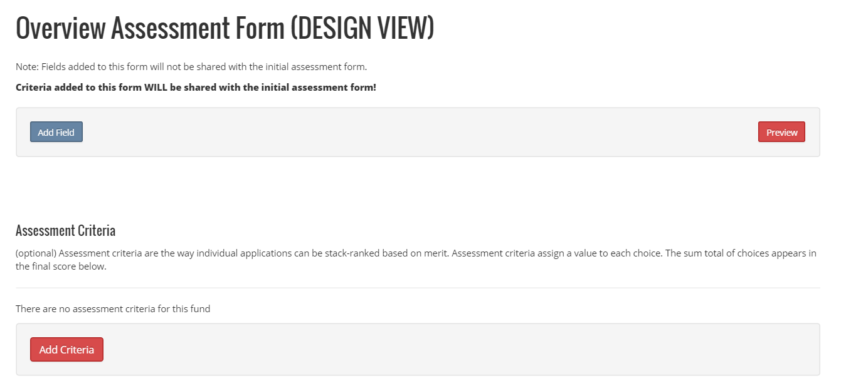
- Fill in the details of the required field
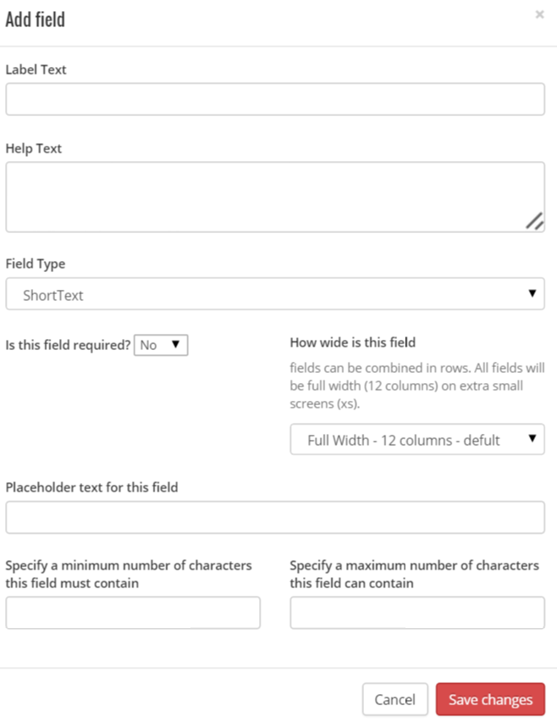
- Click Save Changes

Create an Approval Form
- Click on the Title of the Fund you want to create the approval form
- In Forms Section under Assessment click on Approval Form
- The suggested title of the form is approval form and typically unless you want to change that name you should type approval form
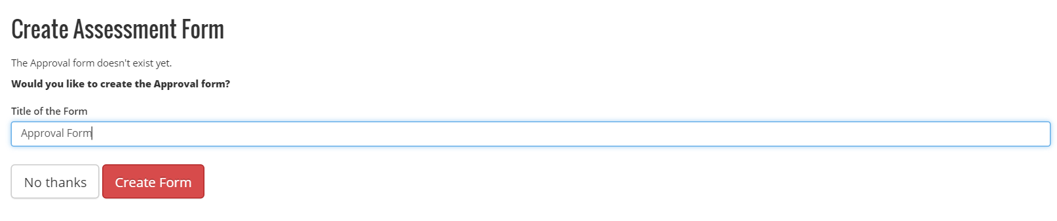
- Click Create Form
- If you require additional fields click Add Field
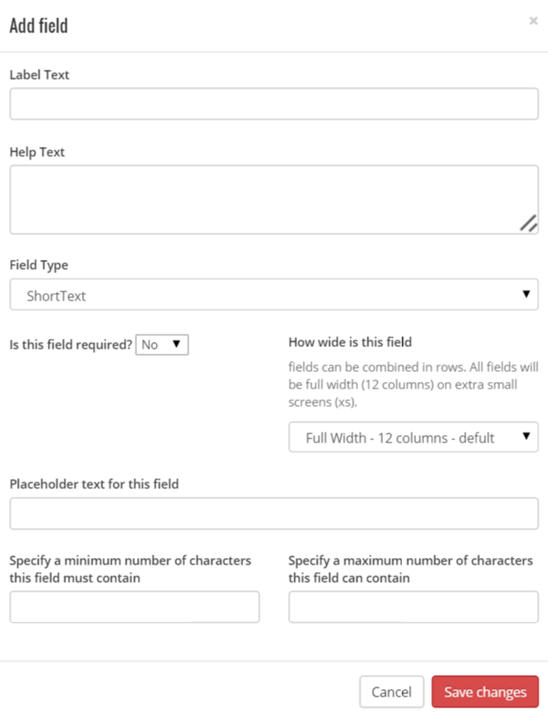
- Click Save Changes

Create a Decision Form
- Click on the Title of the Fund you want to create the decision form
- In Forms Section under Assessment click on Decision Form
- The suggested title of the form is decision form and typically unless you want to change that name you should type decision form
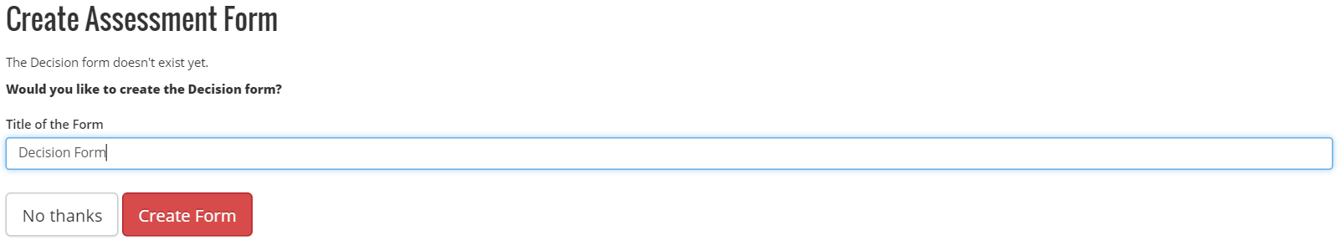
- Click Create Form

Create a Project Report Form
- Click on the Title of the Fund you want to create the project report form
- In Forms Section under Projects click on Project Report Form
- Click Add Field to add the fields required for the report
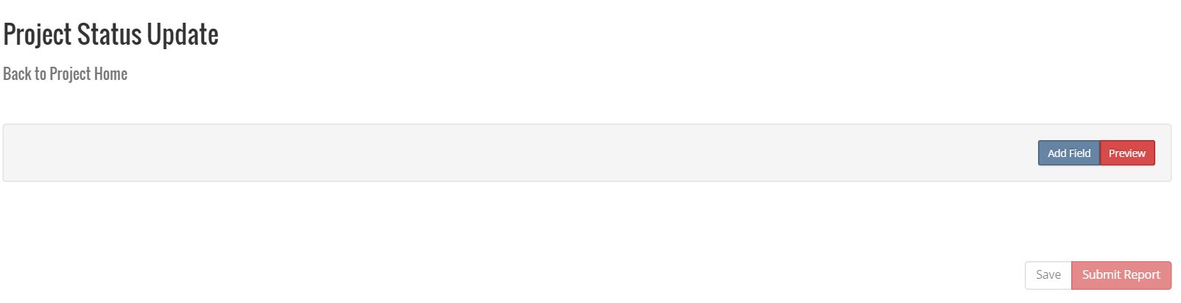
- Fill in the values you require for the field
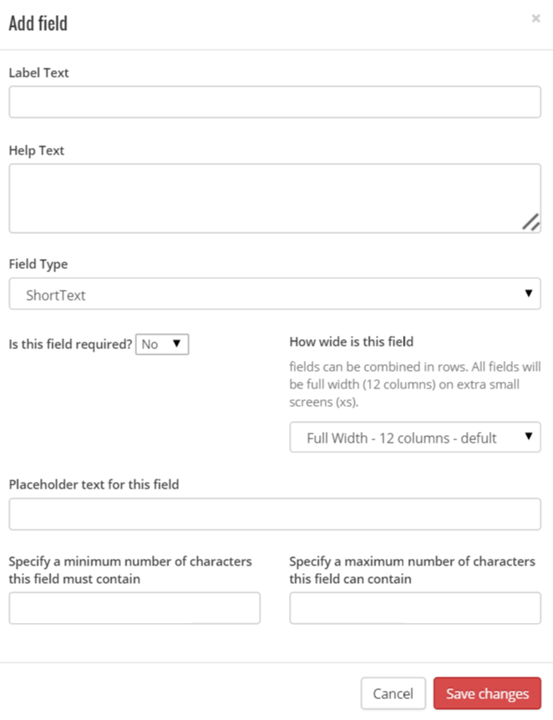
- Click Save Changes
- Repeat Step 4 and 5 till the required fields have been added

Create an End of Project Report
- Click on the Title of the Fund you want to create the End of Project form
- In Forms Section under Projects click on End of Project Form
- Click Add Field to add the fields required for the report
- Fill in the values you require for the field
- Click Save Changes
- Repeat Step 4 and 5 till the required fields have been added

Rounds
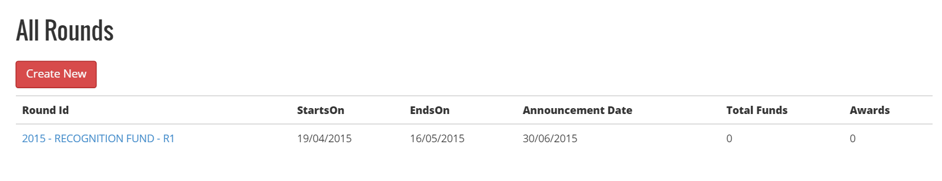

Understanding the Rounds Dashboard
Within the All Rounds dashboard there are a number of columns:
Round ID | This is made up from Year-FundName-RoundID
StartsOn | This is the first date that applications can be submitted for the round
EndsOn | This is the last date that applications can be submitted for the round
Announcement Date | The date the application results will be announced
Total Funds | Total Funds available to the round
Awards | Total funds awarded during the round – awards will not show until the round is finalised

Creating a New Round
- Click Create New
- Select the FundID that the round is for
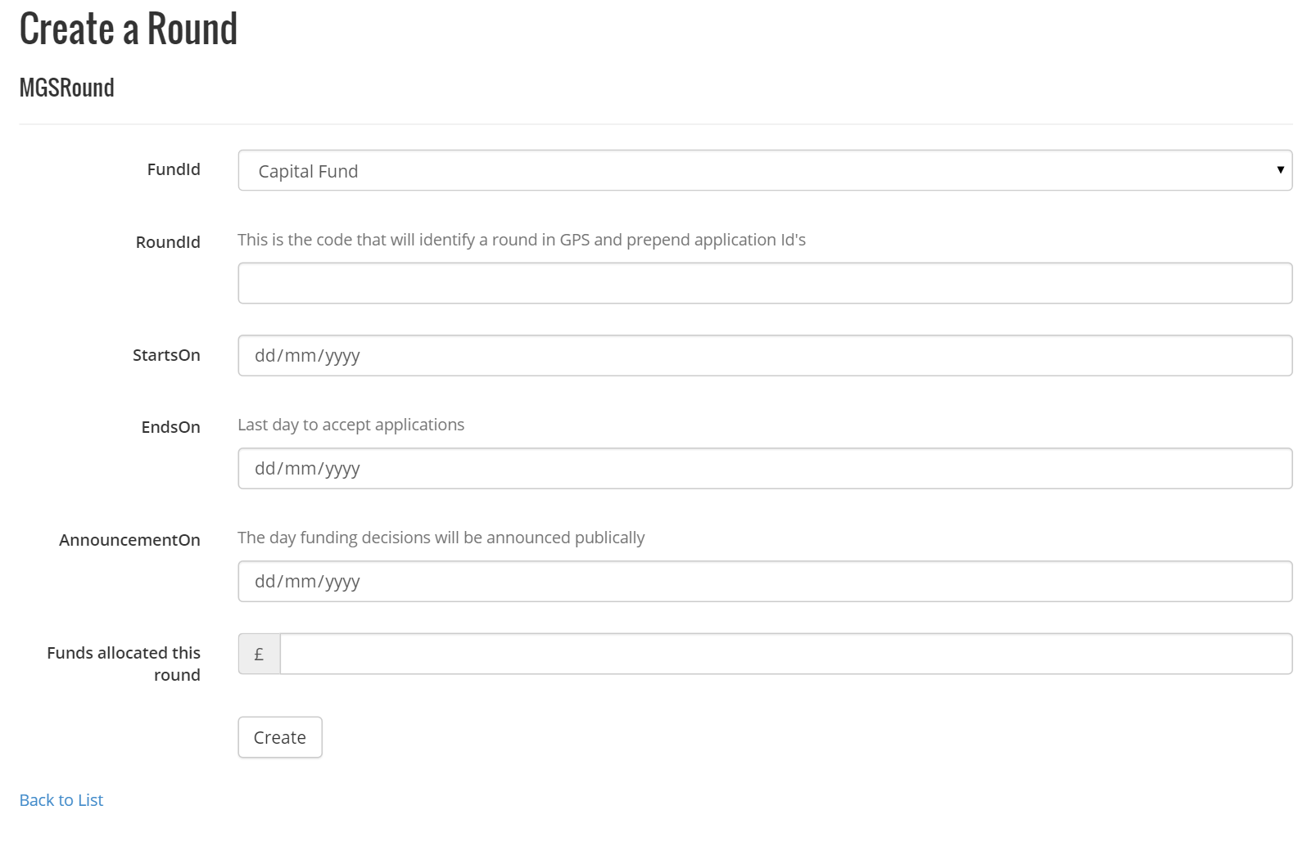
- Use no more than two characters for the round ID Code
- Complete the Starts on and Ends on date
- Complete the announcement date – this date is only for mgs admins reference only
- Complete the funds allocated this round
- Click Create

Managing a Current Round
Clicking on a Round Title will take you into an overview dashboard of the round

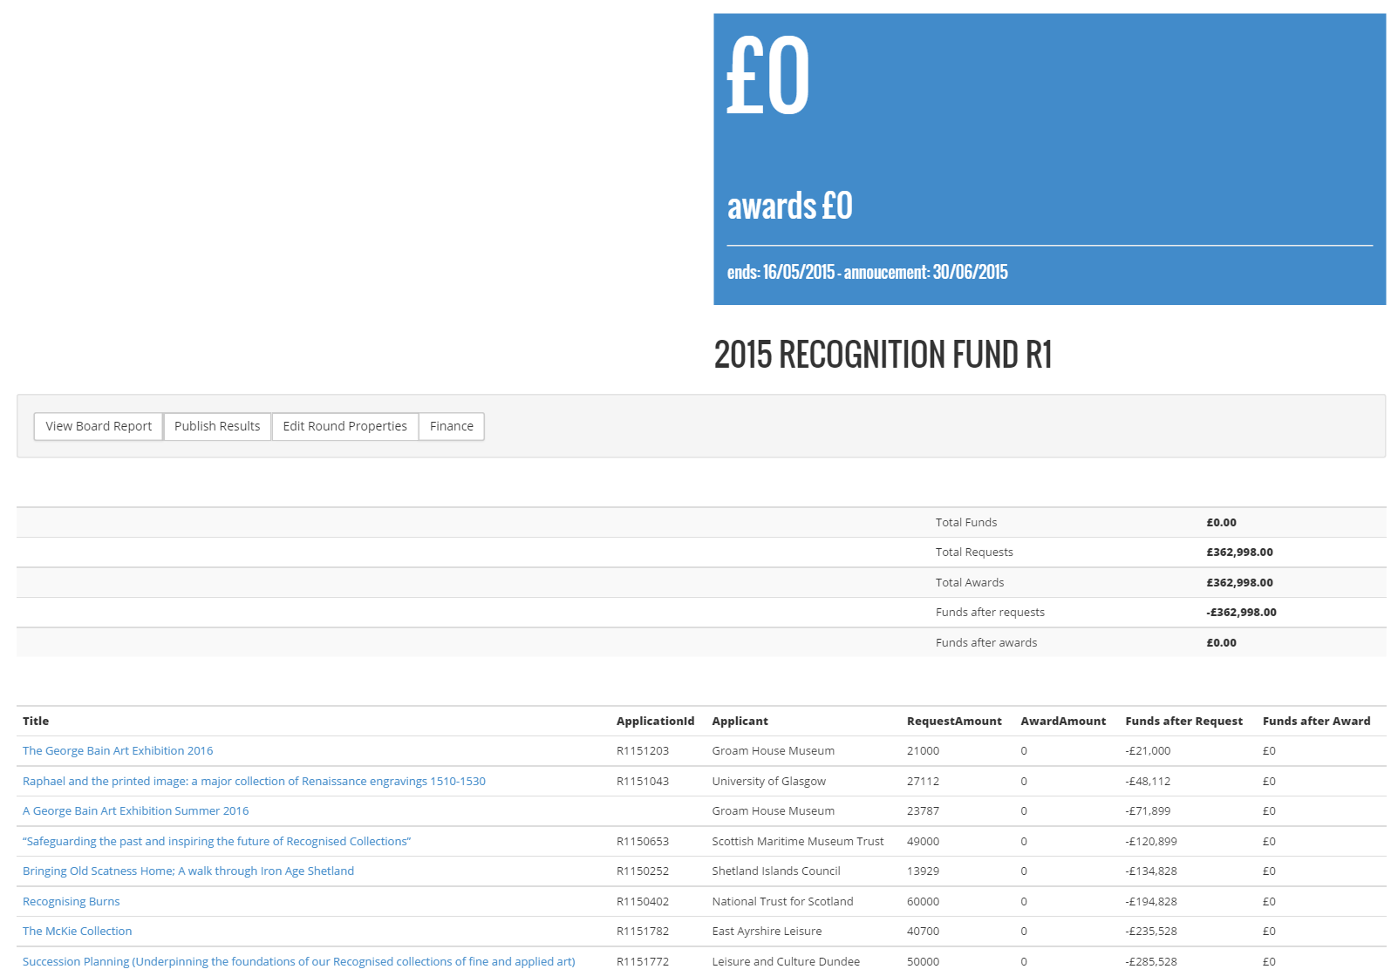
The bottom half of the dashboard shows the applications that have been submitted for the round with the following values
Title | This is the title of the application that the applicant provided
Application ID | This is the rounded-Year-????
Applicant | This is the applicant that submitted the application
Request Amount | This is the amount requested on the application
Award Amount | This is the amount awarded if successful
Funds After Request | This is a running fund total of the amounts requested
Funds After Award | This is a running total of amounts awards

The middle of the dashboard shows 5 totals:-
Total Funds
Total Requests
Total Awards
Funds After Requests
Funds After Awards

Reopen a Round
On certain occasions it may be necessary to reopen an existing round to allow a late application.
- From the Rounds Dashboard click the round you wish to amend
- Click Edit Round Properties
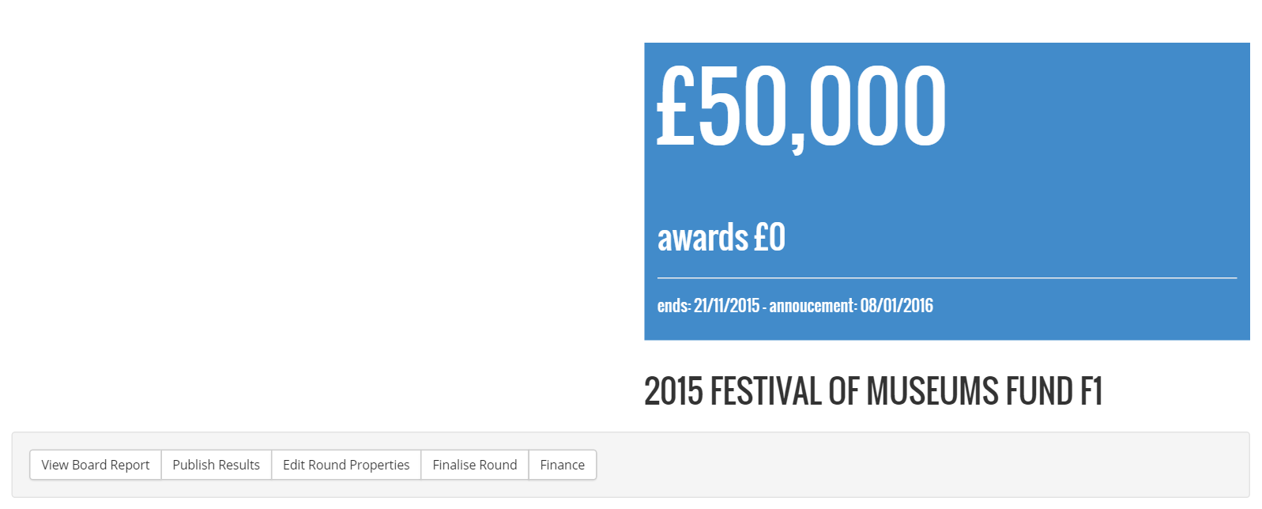
- Amend the date in the Ends On field
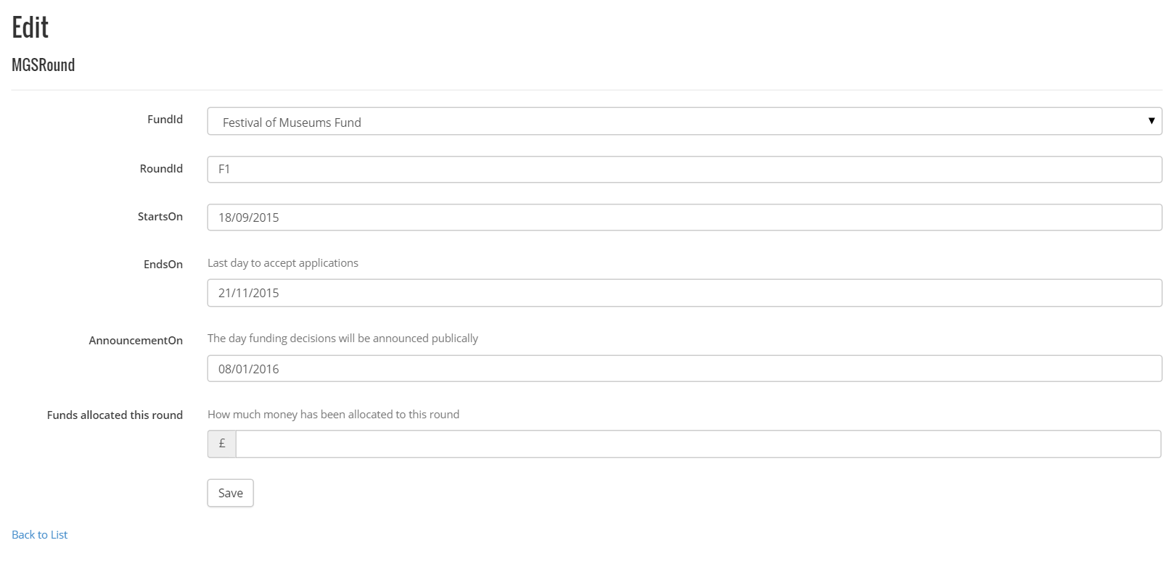
- Click Save

Creating a Board Report
The board report can be created by a gps admin once the round has been finalised and can be obtained by clicking on the Board Report button within the relevant round

Publishing Results of a Round
<>

Edit Round Properties
- Click on Edit Round Properties within the relevant round
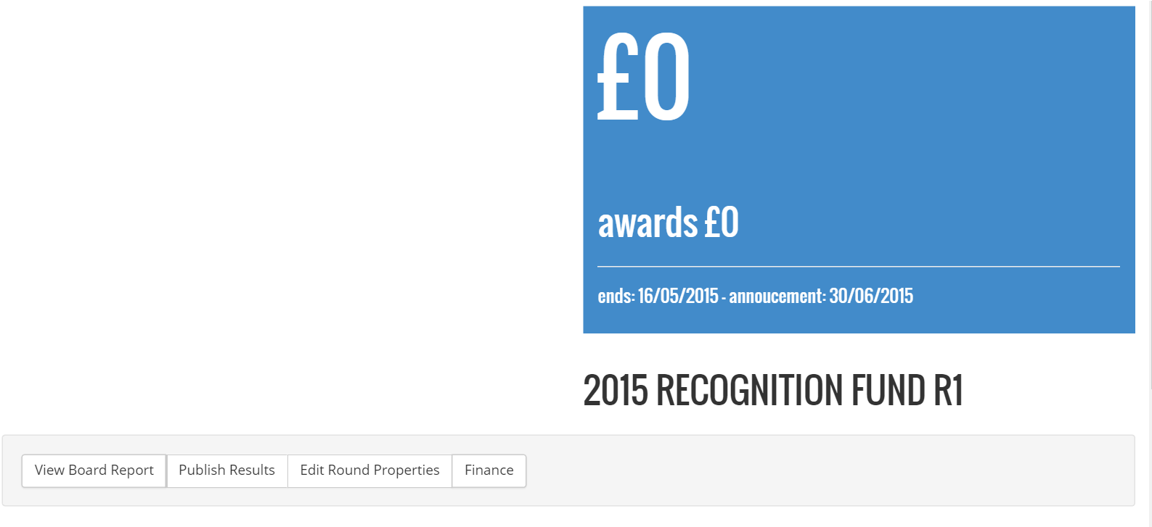
- Edit the fields requiring amendment
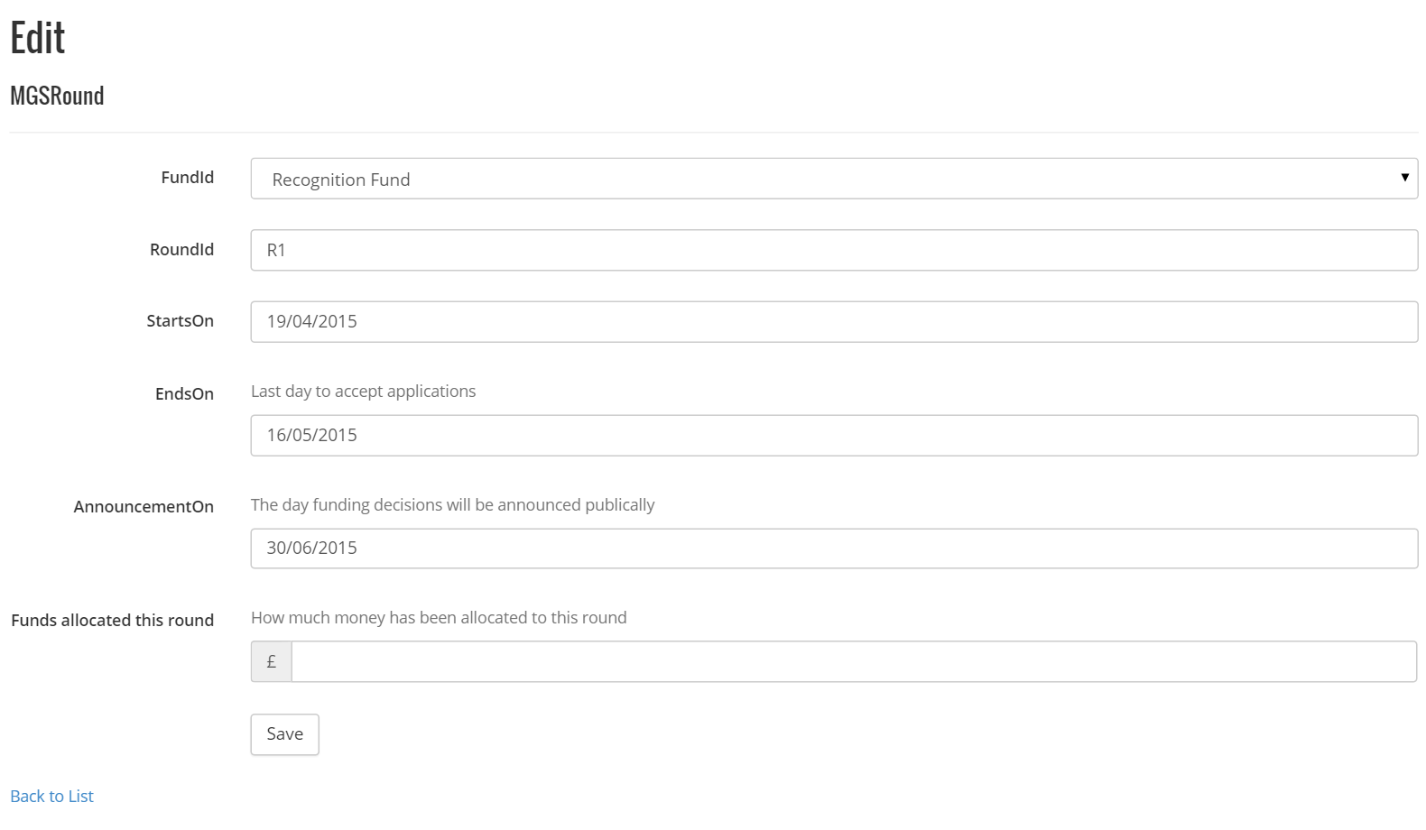
- Click Save

How to Run Finance Round Report for Sage Export
There are three main reports that Finance require to export and import into their Sage accounts package:-
- Finance Round Report
- Claims Report
- Slippage Report
The Finance Round Report is used to show the allocated funds that have been awarded within the round. Funds are processed based on rounds. When a round is finalised it locks the round.
- Click on Finance within the relevant round
- A summary will show the applications and the amount awarded
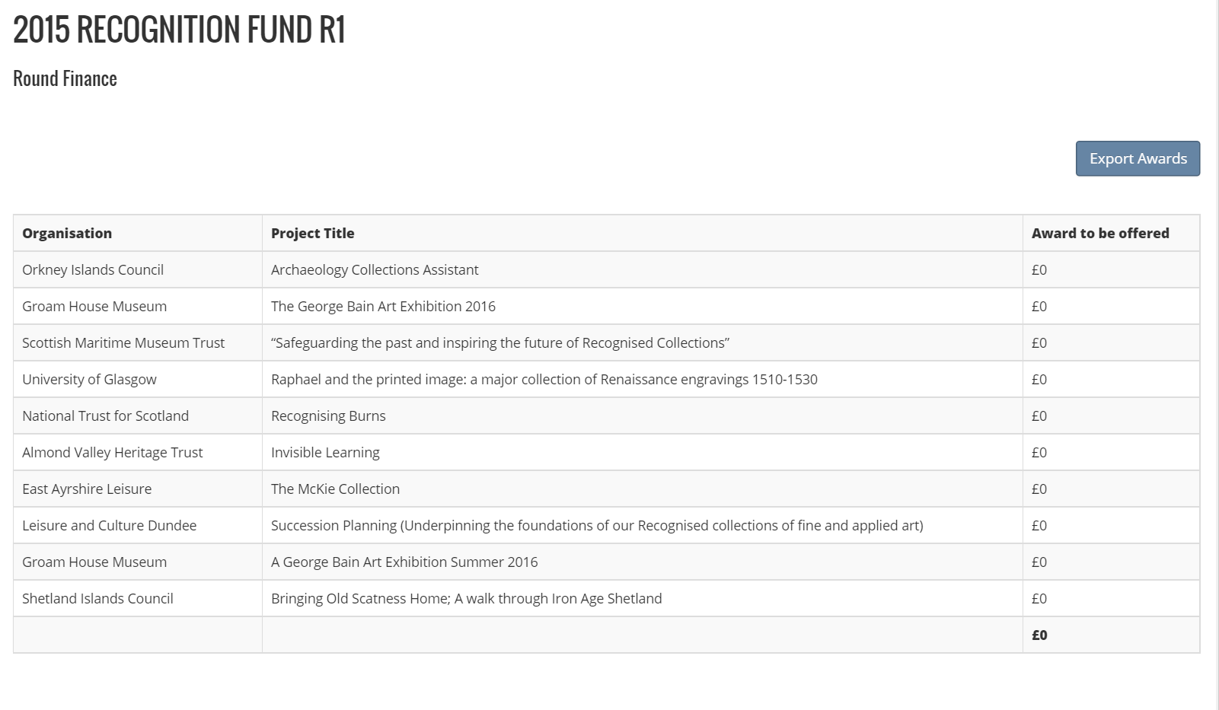
- Click export awards
- The awards will download to a file that can be sent to Finance

Grants
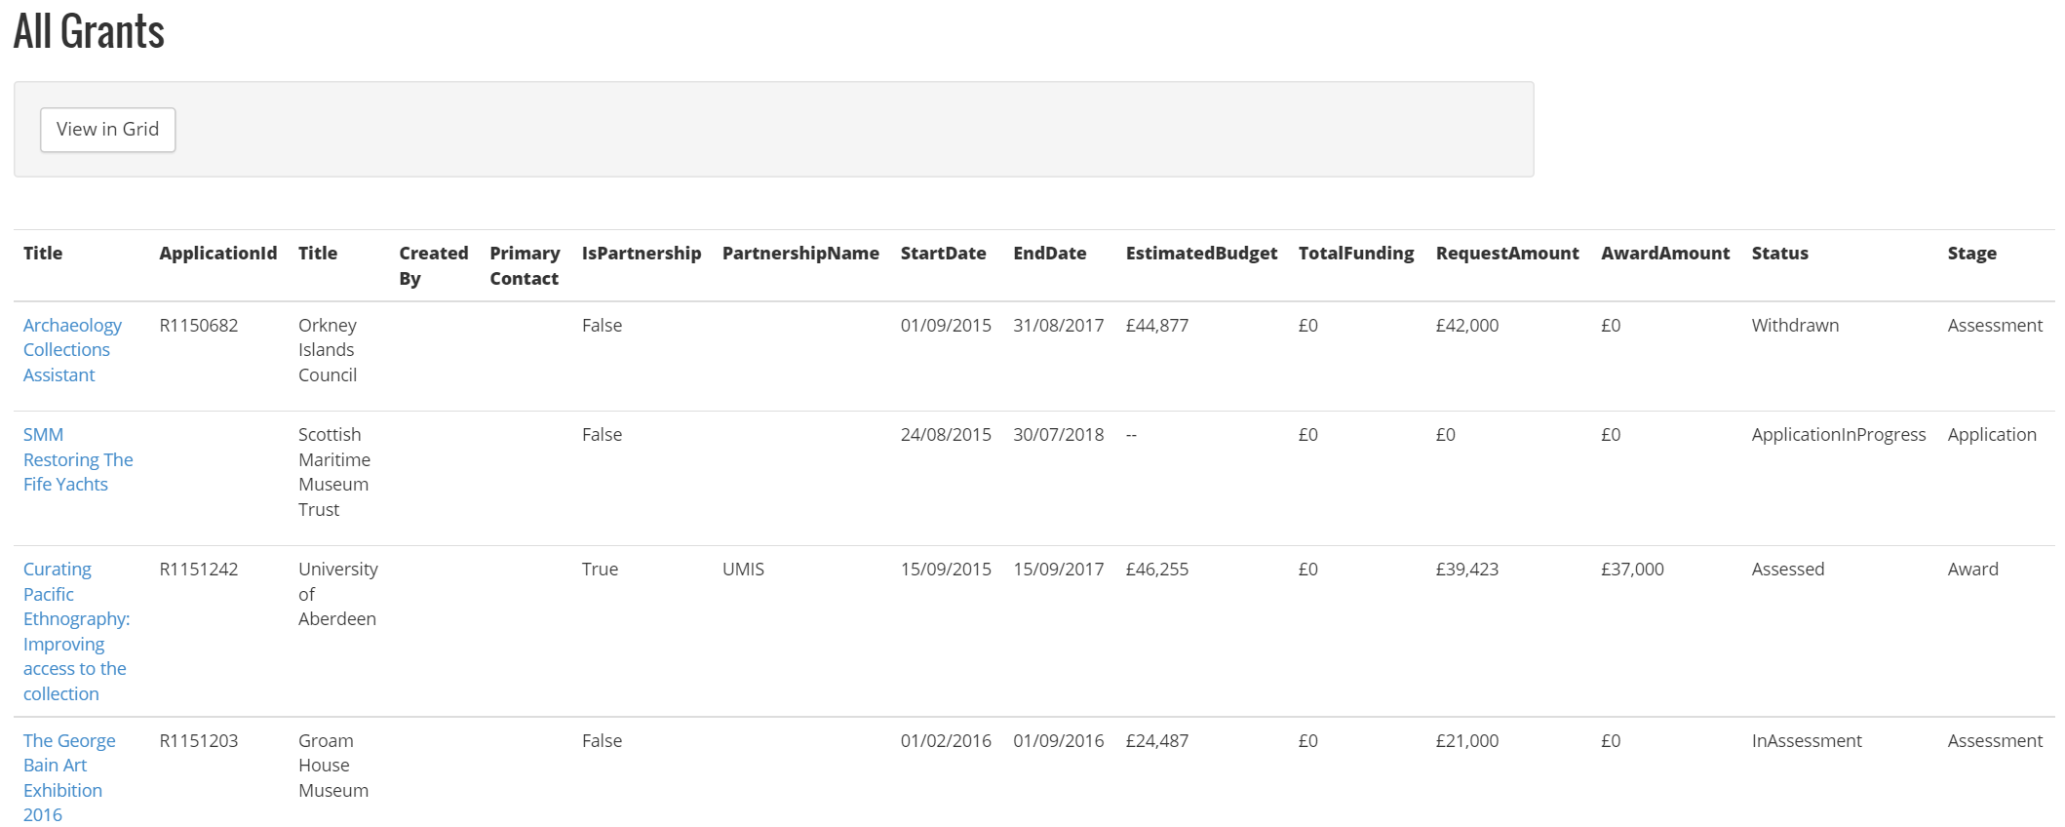

Understanding the Grants Dashboard
The all grants dashboard shows all applications on GPS. Within the All grants dashboard there are a number of columns:
Title | This is the title of the application that the applicant provided
Application ID | This is the rounded-Year-????
Title | This is the application that submitted the applications
Created By
Primary Contact
Is Partnership | Shows whether application is on behalf of a partnership
Start Date | Is the date the applicants project will start
End Date | Is the date the applicants project will complete
Estimated Budget | Is the amount the applicants project will cost
Total Funding | ?
Request Amount | Is the amount the applicant has requested
Award Amount | Is the amount the applicant has been awarded
Status | Shows the stage the project is at
Stage | Shows the stage the project is at

Grid Mode
Clicking View in Grid allows you to filter all grants by:-
Organisation
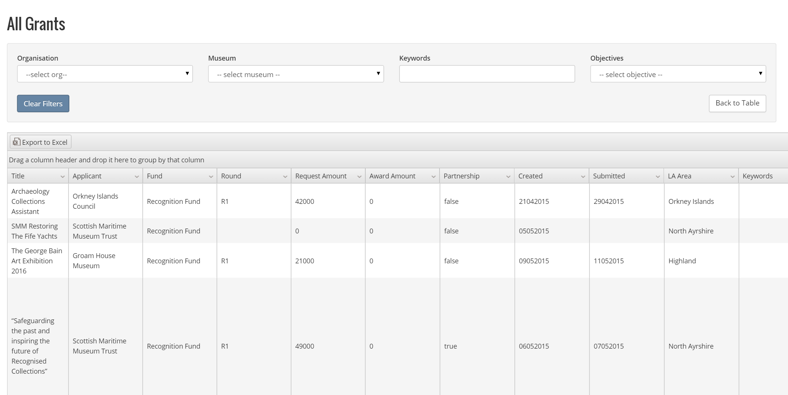
Clicking on the Export to Excel button will export all the grants based on your filters to excel. If you have no filters it will export all the grants.

Clicking on back to table will take you back to the All Grants Dashboard

Complete a Grant/Project
- From within the All Grants page, click on the grant you wish to finalise

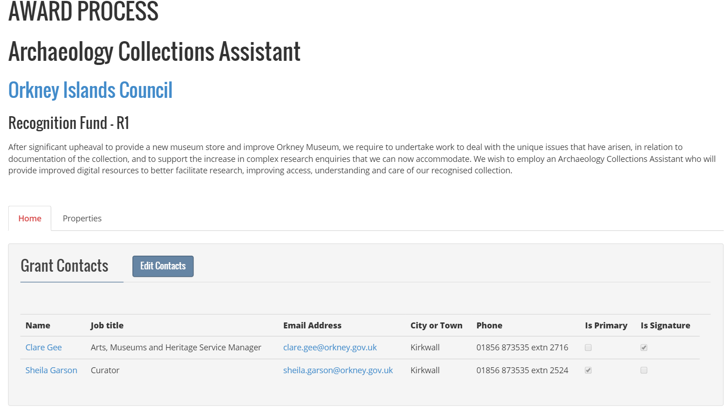
- Click on the Properties Tab above the Grant Contacts Details section

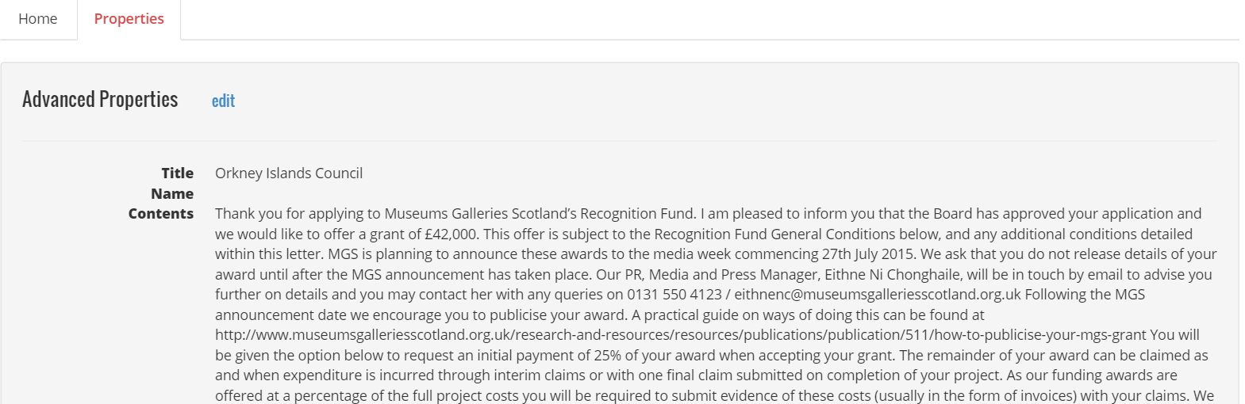
- Click Edit next to Advanced Properties
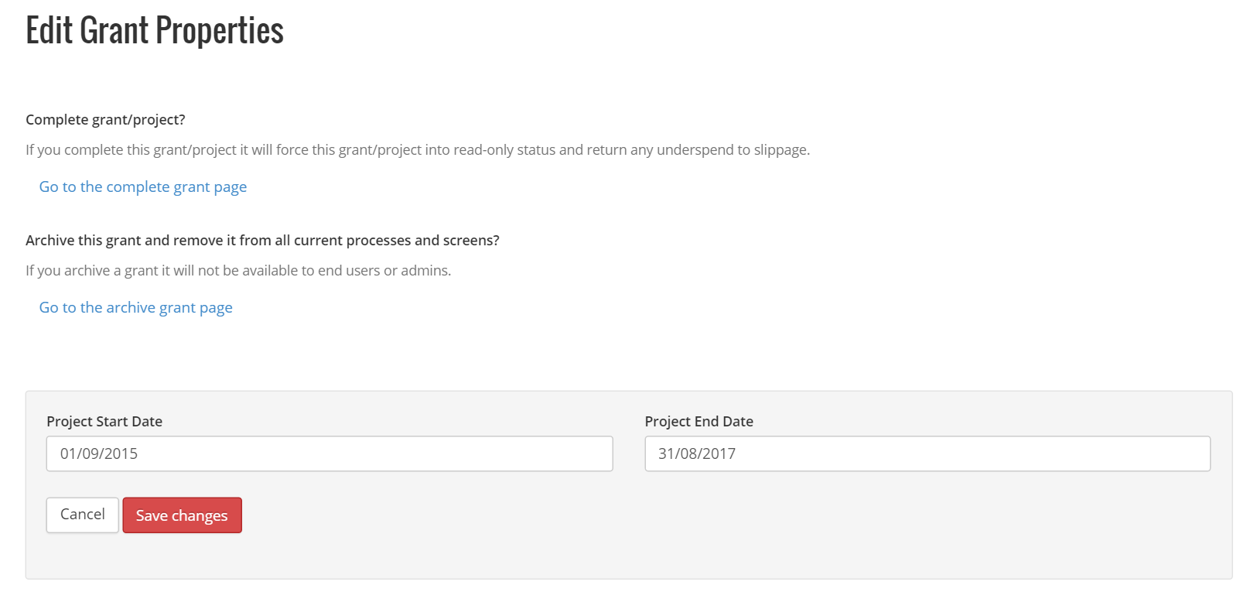
- Click Go to the complete grant page

Assessments
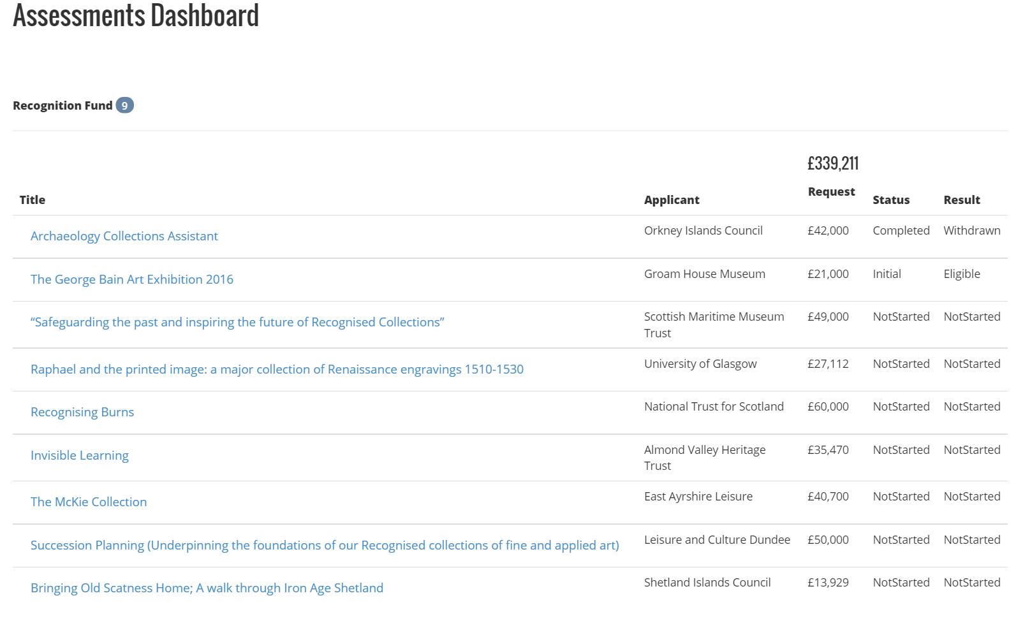

Understanding the Assessments Dashboard
The assessment dashboard is where all grant applications that have passed the eligibility check will present.
The assessments are sorted by Fund. It will show the Fund Name and the total assessments then the assessments in that category.
There may be times when there will be more than one Fund with assessments
Within the assessments dashboard there are a number of columns:
Title | This is the title of the application that the applicant provided
Applicant | This is the rounded-Year-????
Request | This is the applicant requested amount
Status | The stage the assessment process is at:-  Not Started  Withdrawn  Eligibility  Initial  Completed
Result | The result for the stage the assessment process:-  Not started  Eligible  Not Eligible  Recommended  Strongly Recommended  Not Recommended  Completed

Starting the Eligibility Check for a Submitted Grant
- From within the Assessment Dashboard click the grant from within the round you wish to start the assessment
- Click View Application to view the application with the option to print
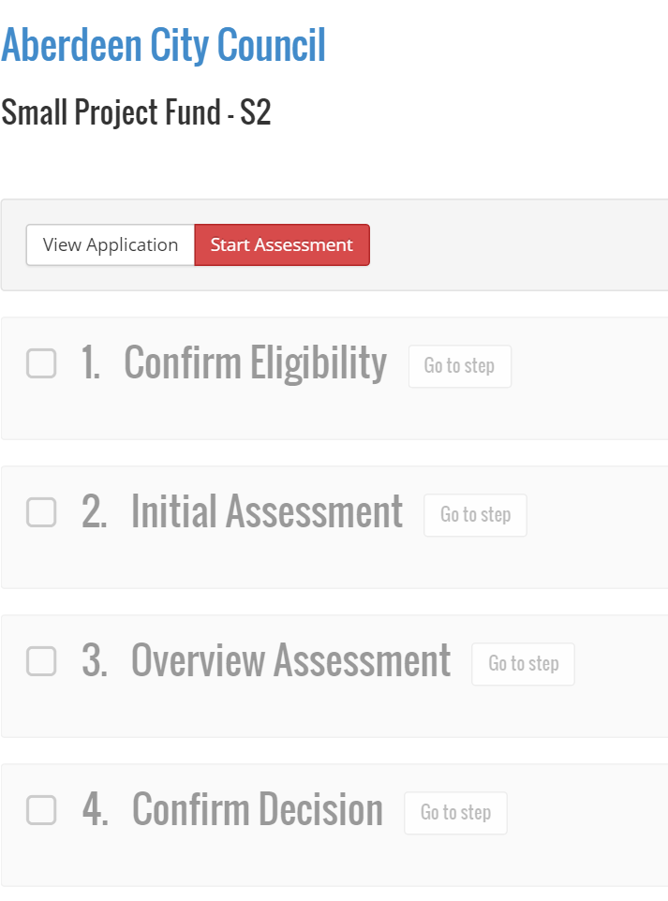
- Click Start Assessment
- Click Confirm eligibility
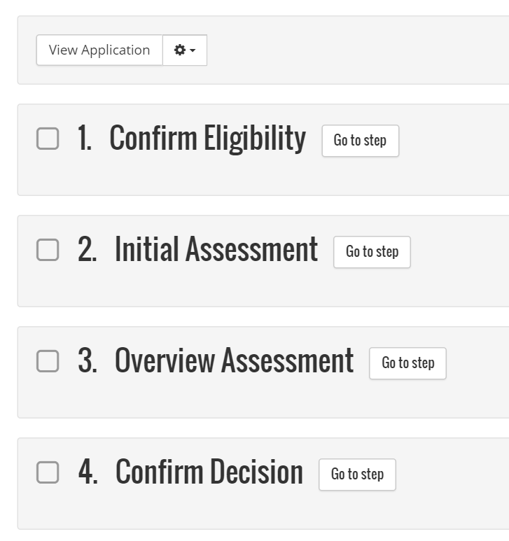
- Complete the fields that were defined for the eligibility form for the round
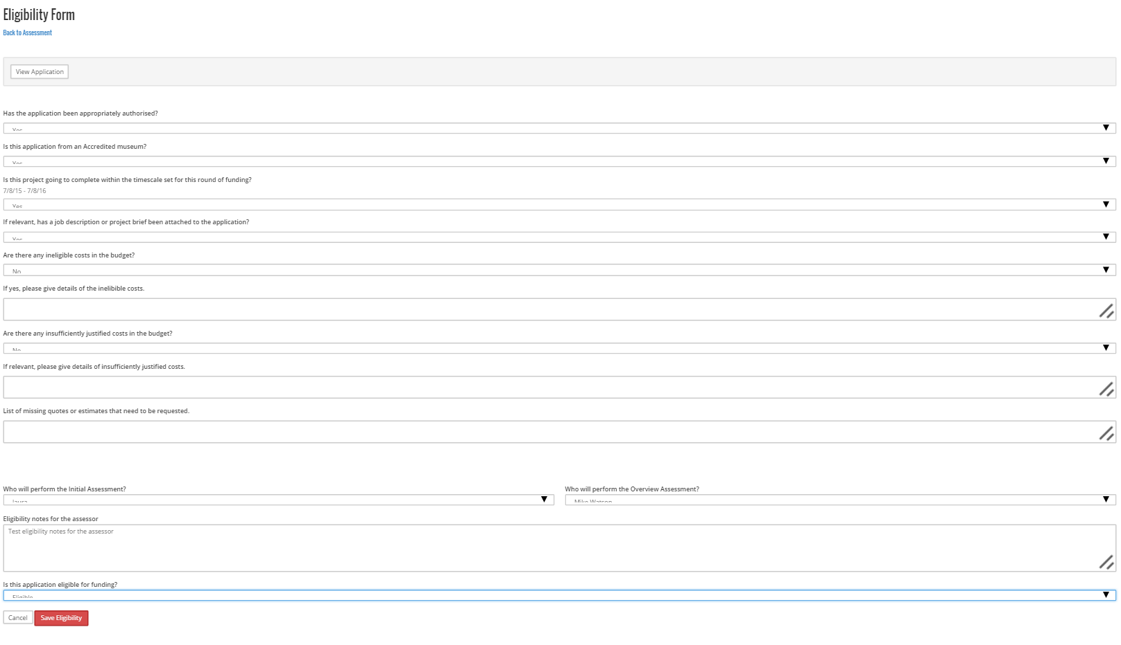
NoteIf the person you are not looking for is not on the dropdown assessor list they haven’t been added to the relevant user Group
- Ensure you select and Initial Assessor and an Overview Assessor

- Click Save Eligibility
- Click Confirm Eligibility
The Assessments Dashboard will now show the new state of the Grant application
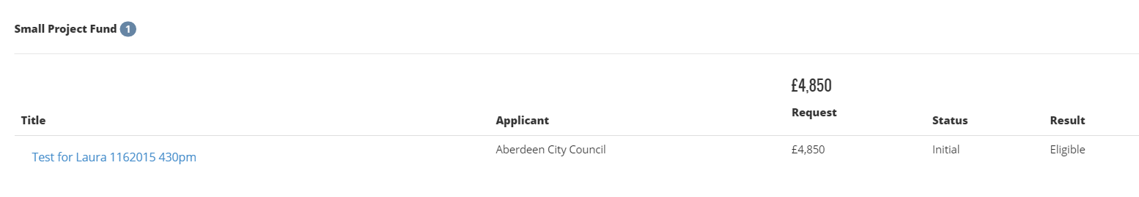

Starting the Initial Assessment Check for a Submitted Grant
Once a grant has passed the eligibility check an email will be sent to the initial assessor to advise them they have an initial assessment to carry out
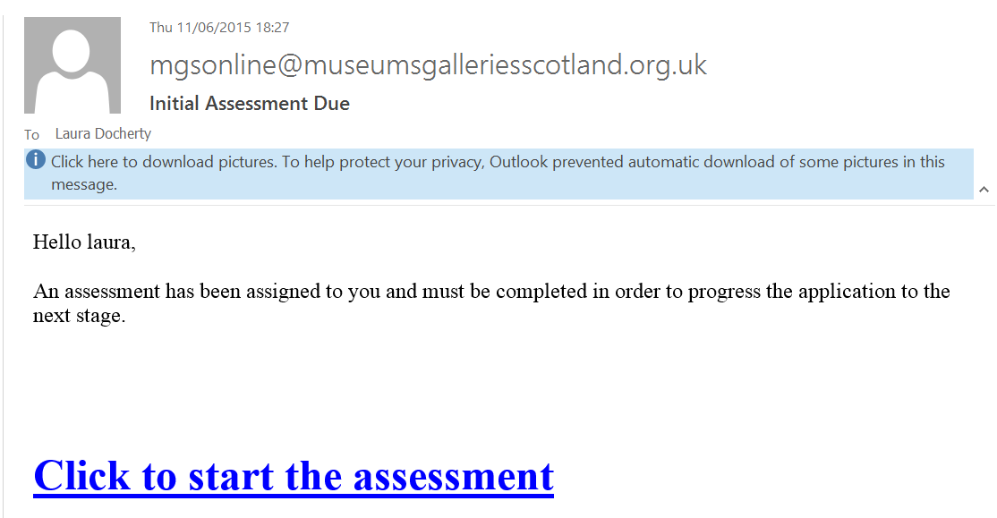
- If you haven’t already logged in to the GPS system Log In
- Click the email link “Click to Start the Assessment”
- In the Initial Assessment step Click Go To Step
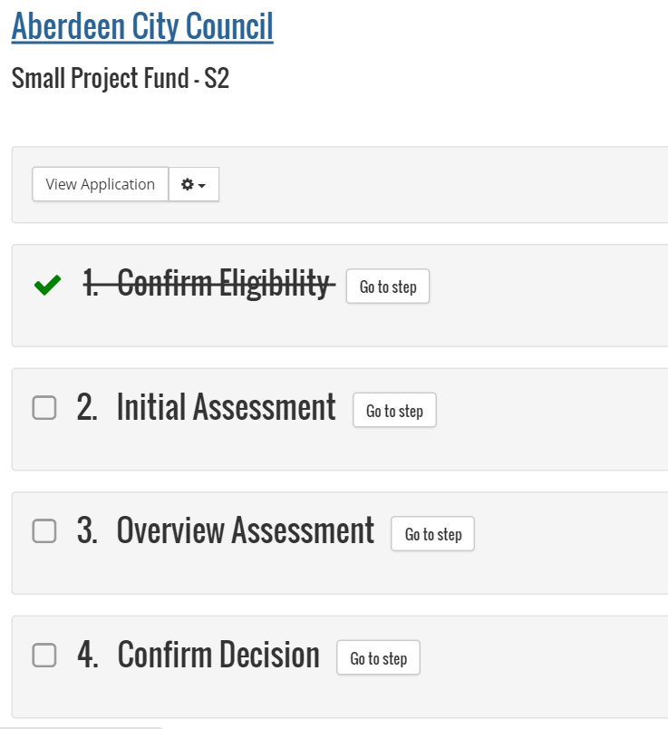
- Click View Application to view the application with the option to print
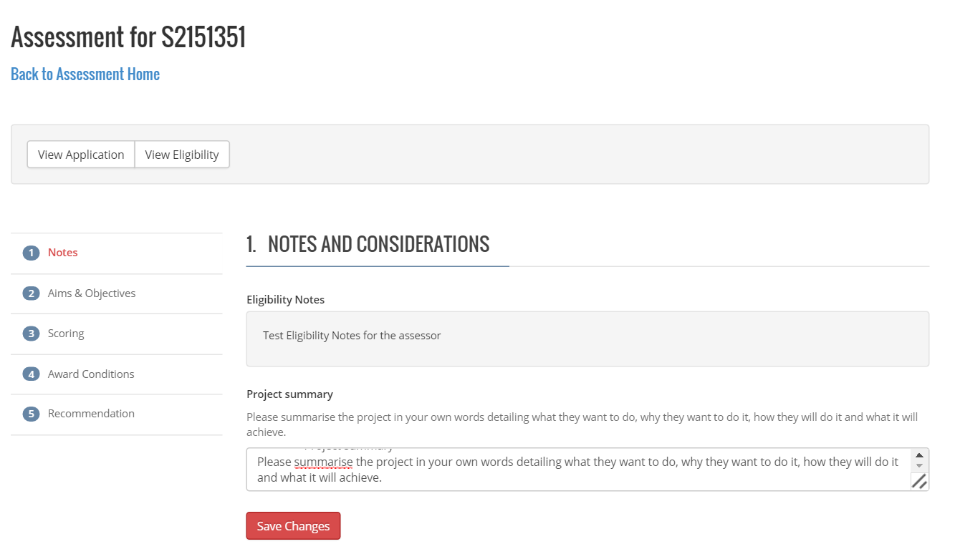
Note
The eligibility view will open in a separate browser tab to allow you to view the eligibility whilst working through the assessment
- You can view the eligibility by clicking on View Eligibility

- Read the through the eligibility notes and complete the Project Summary (in your own words) in the Notes and Considerations step
- Complete the Aims and Objectives step
- Complete the Scoring step
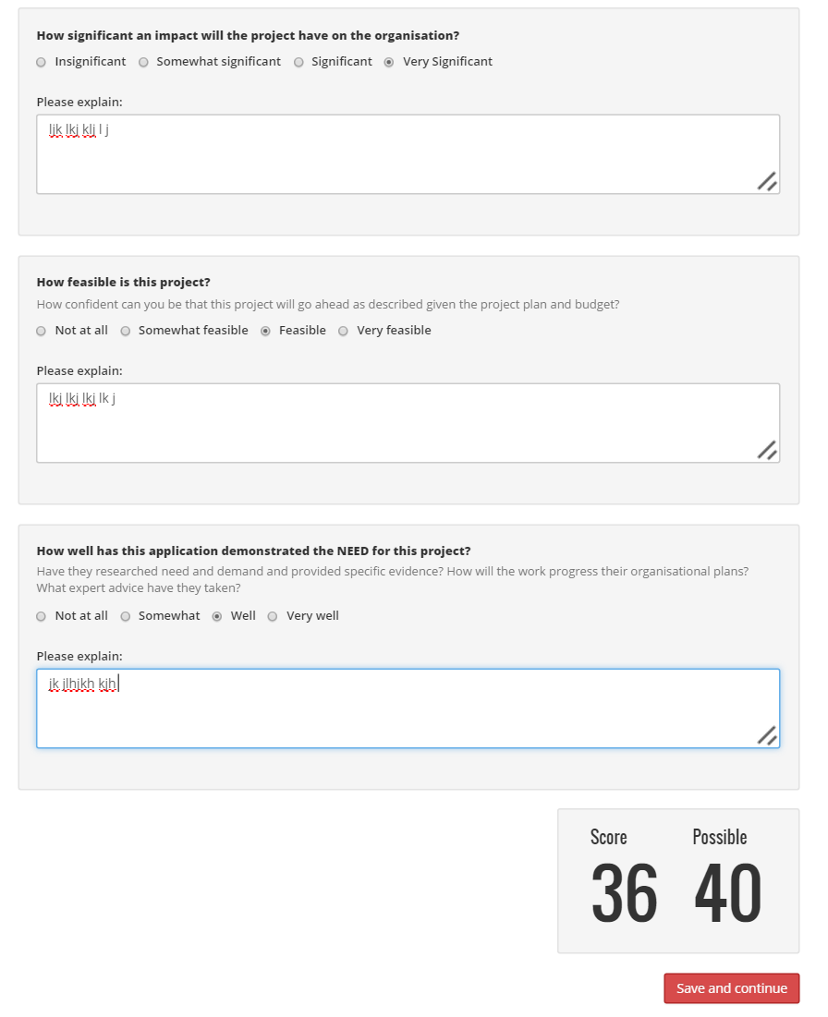
- Each question response carries a score and the total is showing at the end of the questions together with the Possible Amount achievable.
- Click Save and Continue
- Complete the Award Conditions Step ensuring to add all award conditions
- Click Save and Continue
- Complete the Recommendation Step
- Click Save Assessment
- Review your recommendation and Click Submit Assessment
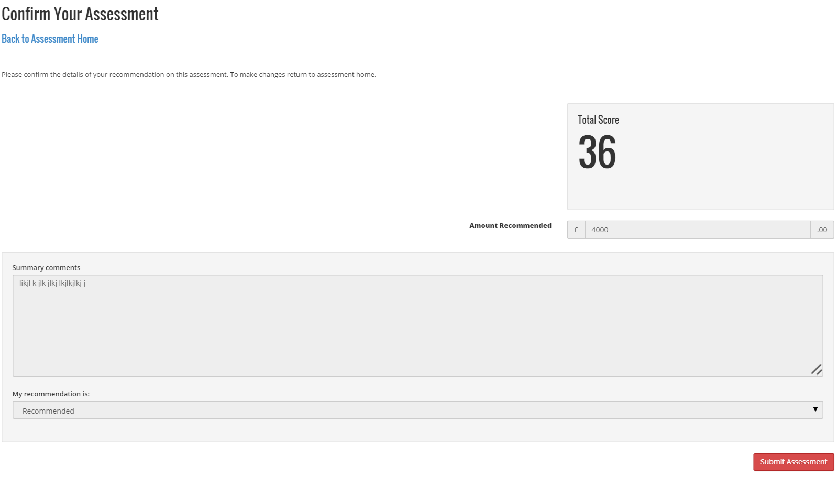
The assessments dashboard will now show the grant status based on your recommendation
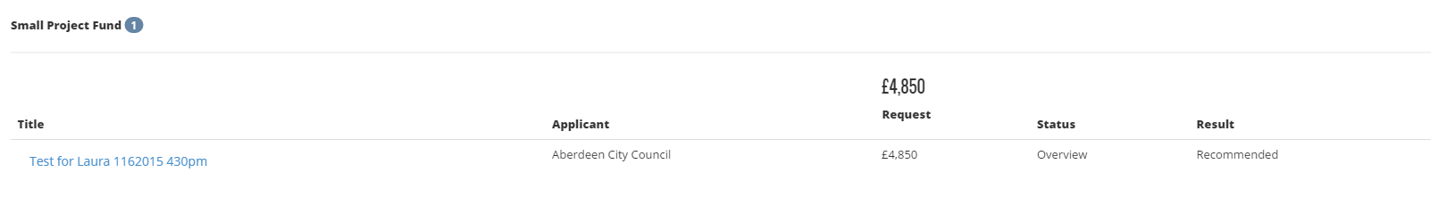

Starting the Overview Assessment for a Submitted Grant
Once a grant has had the initial assessment completed an email will be sent to the overview assessor to advise them they have an initial assessment to carry out
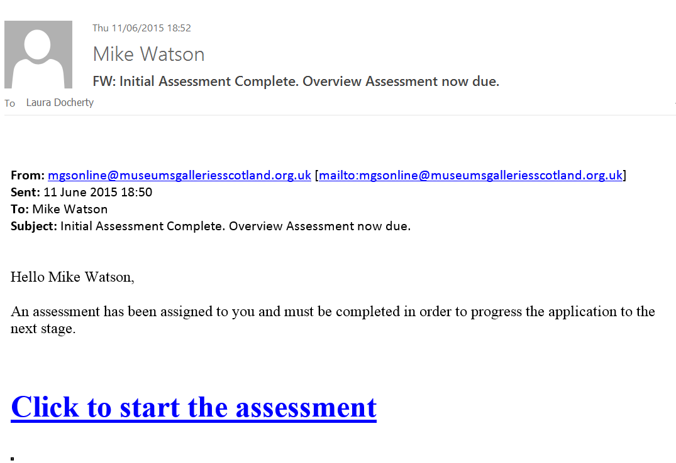
- If you haven’t already logged in to the GPS system Log In
- Click the email link “Click to Start the Assessment”
- In the Overview Assessment section Click Go To Step
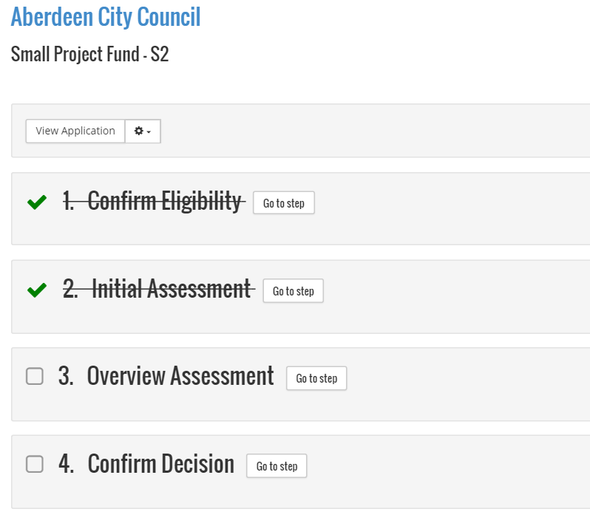
- Click View Application to view the application with the option to print
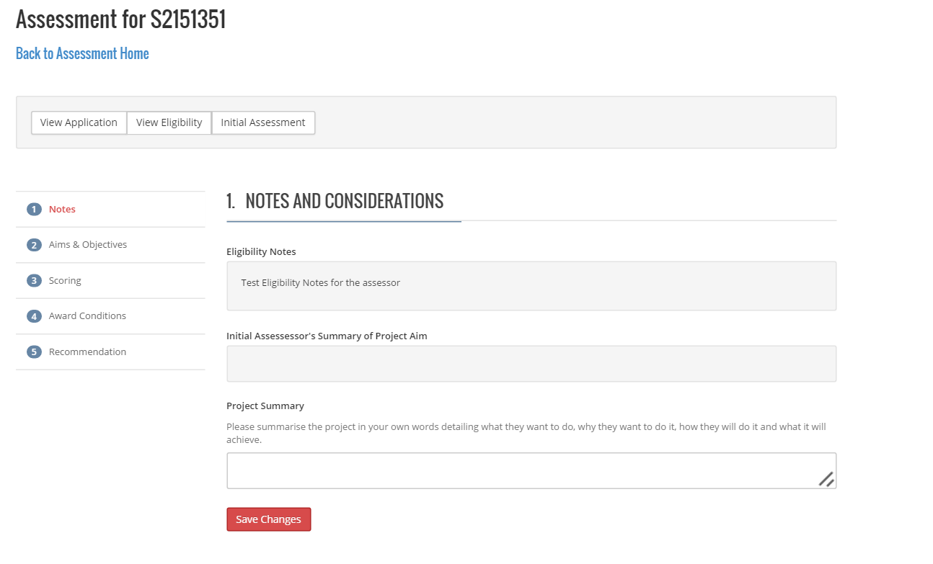
Note
The initial assessment view will open in a separate browser tab to allow you to view the initial assessment whilst working through the assessment
Note
The eligibility view will open in a separate browser tab to allow you to view the eligibility whilst working through the assessment
- You can view the eligibility by clicking on View Eligibility

- You can view the initial assessment by clicking on Initial Assessment
- Complete the Aims and Objectives step
- Complete the Scoring step
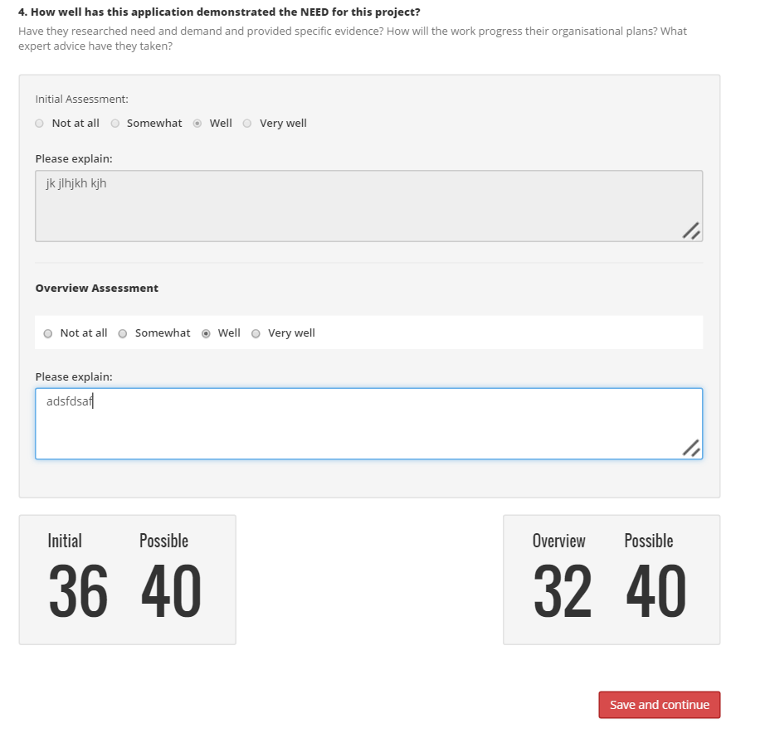
- Each question response carries a score and the overview total is showing at the end of the questions together with the initial assessment total.
- Click Save and Continue
- Complete the Award Conditions adding any additional conditions required
- Click Save and Continue
- Complete the Recommendation
- Click Save Recommendation
- Review the recommendation
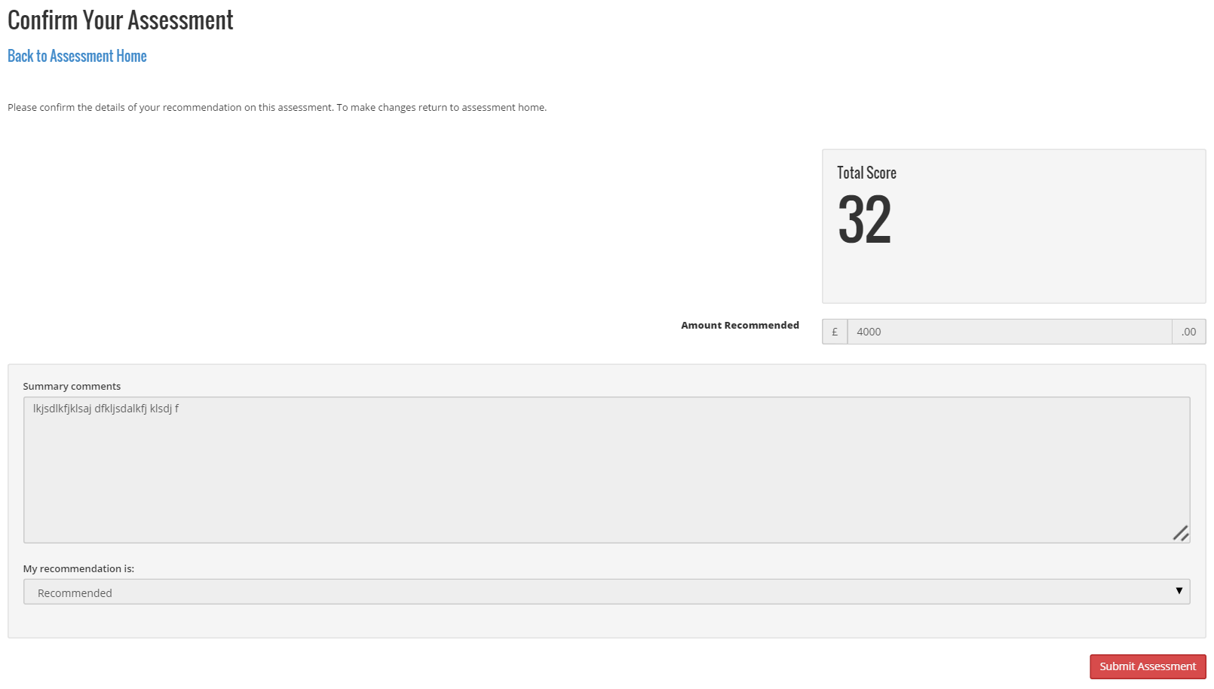
- Click Submit Assessment

Confirm the Assessment Decision for a Submitted Grant

- Within Confirm Decision Click Go To Step
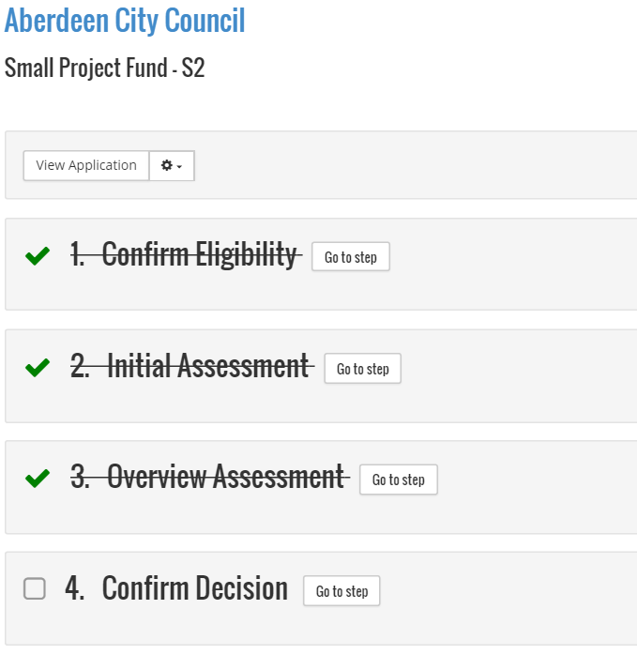
- Complete the section Decision Letter Comments
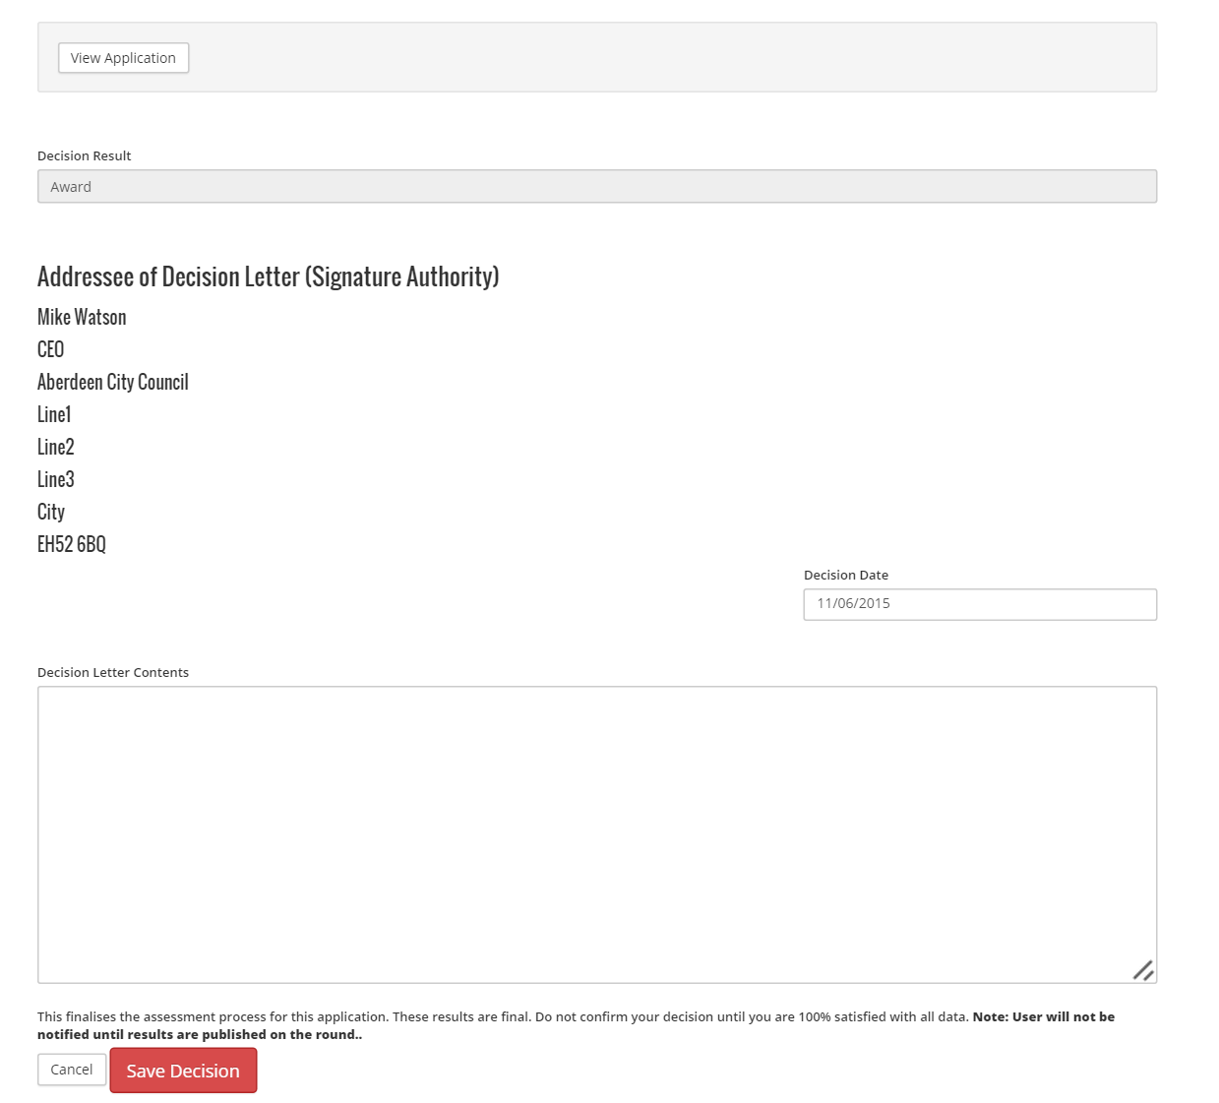
Note
Applicant submitter will not be notified of any award until results are published for the round
- Click Save Decision
- Click Confirm Decision

Awards
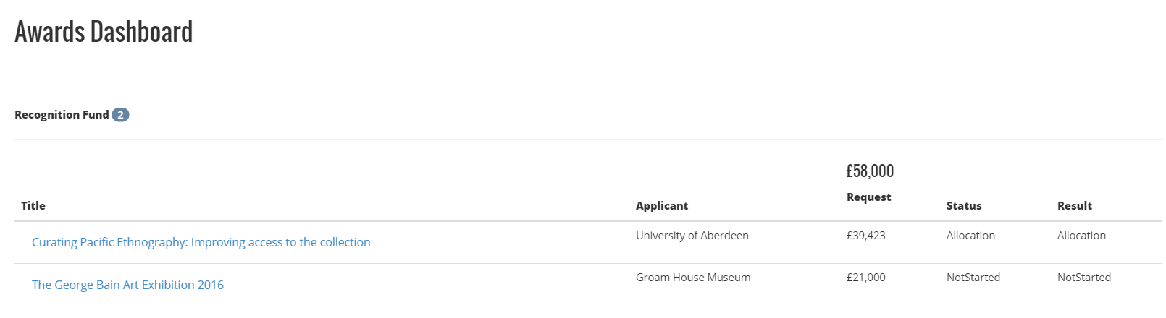

Understanding the Awards Dashboard
The awards dashboard is where all applications that have been awarded will present.
The awards are sorted by Fund. It will show the Fund Name and the total awards then the awards in that category.
There will be times when there will be more than one Fund with awards
Within the awards dashboard there are a number of columns:
Title | This is the title of the application that the applicant provided
Applicant | This is organisation the applied
Request | This is the requested amount on the application
Status | This will show the stage of the award phase
Result | This will show the result of the award phase

Allocating an Award to a submitted grant
- From within the Awards Dashboard click the grant from within the round you wish to allocate an award
- Click to view the application
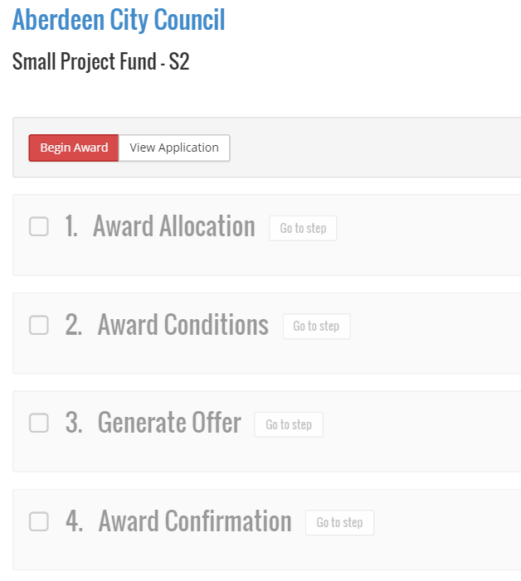
- Click Begin Award
- Within Award Allocation click Go To Step
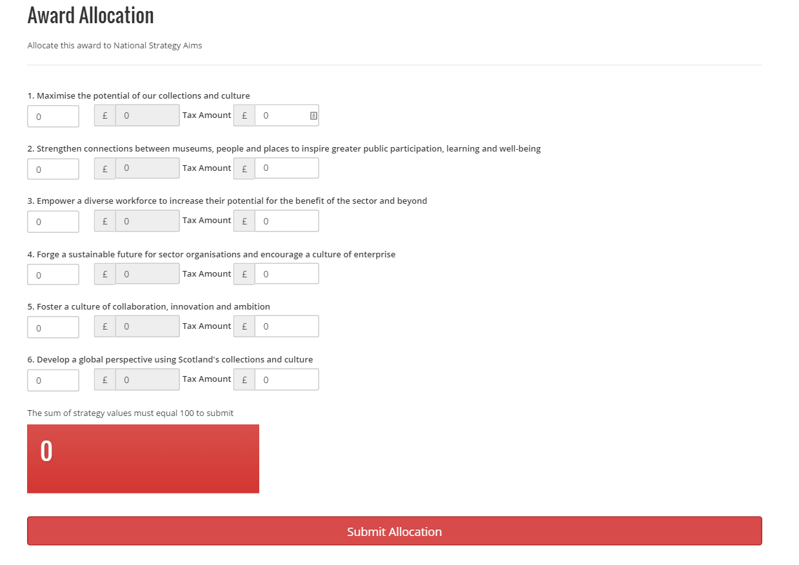
- Allocate the percentage amount to each aim. The total across the aims must equal 100 or the calculation box will not turn to green.
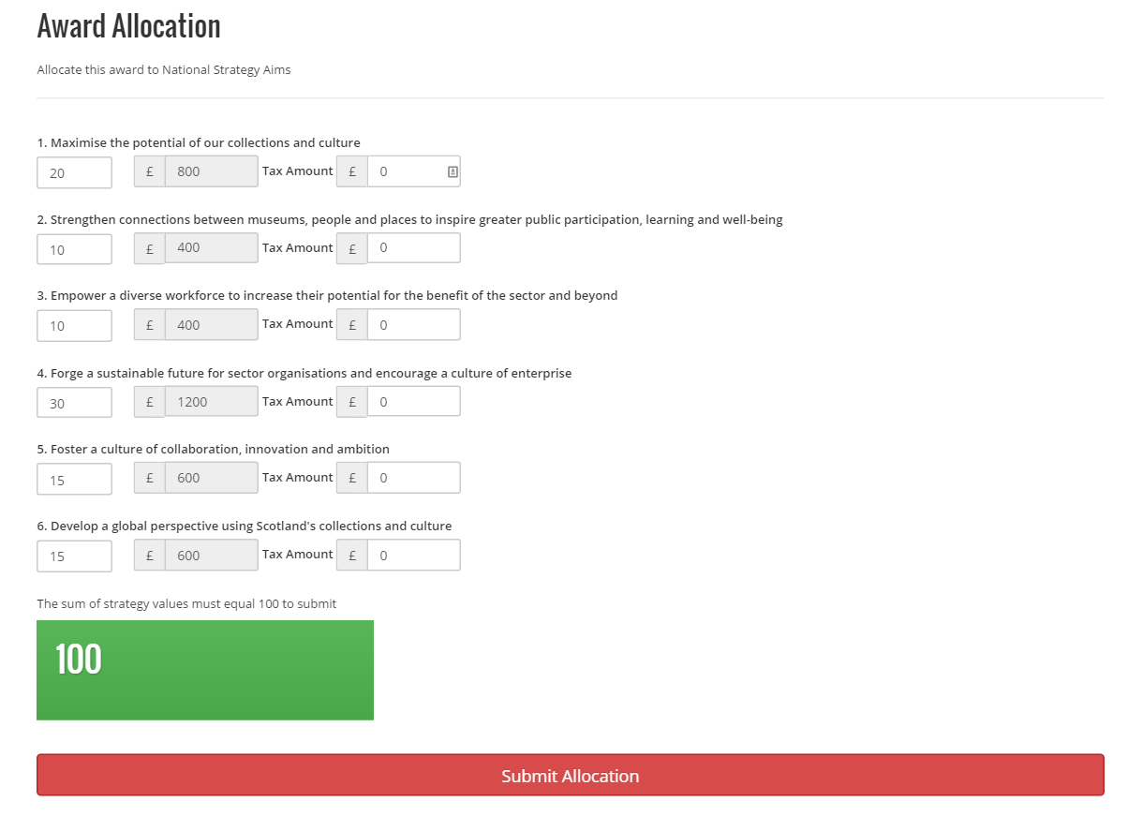
- Click Submit Allocation
- Within Award Conditions click Go To Step
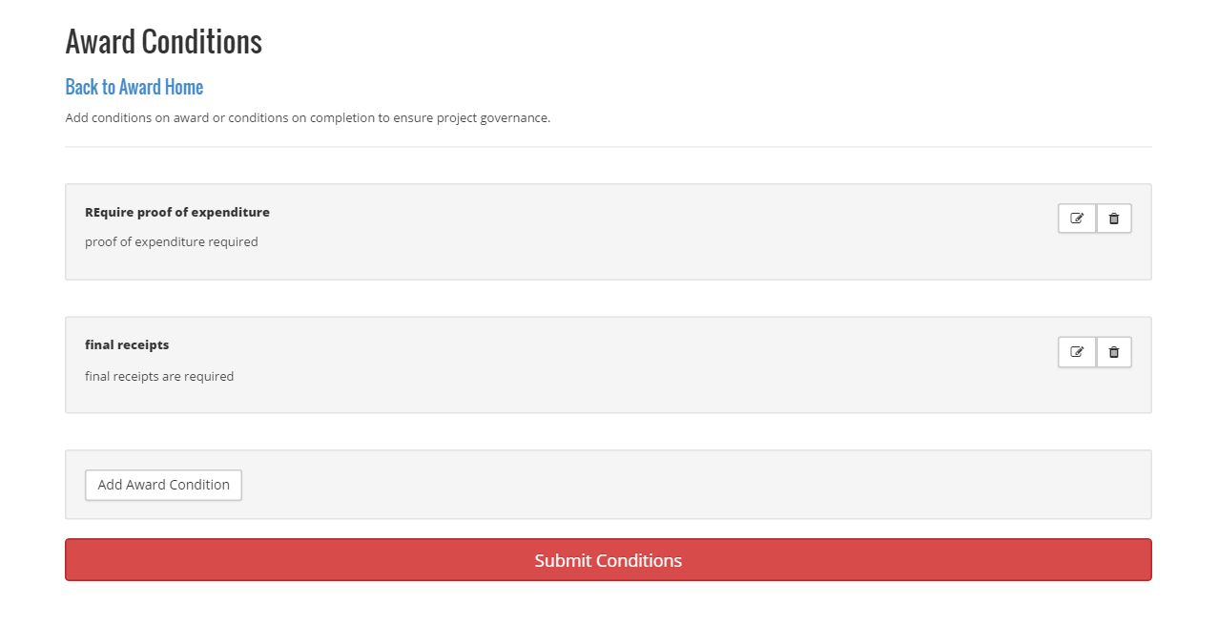
- Add any additional award conditions
- Click Submit Conditions
- Within Award Offer click Go To Step
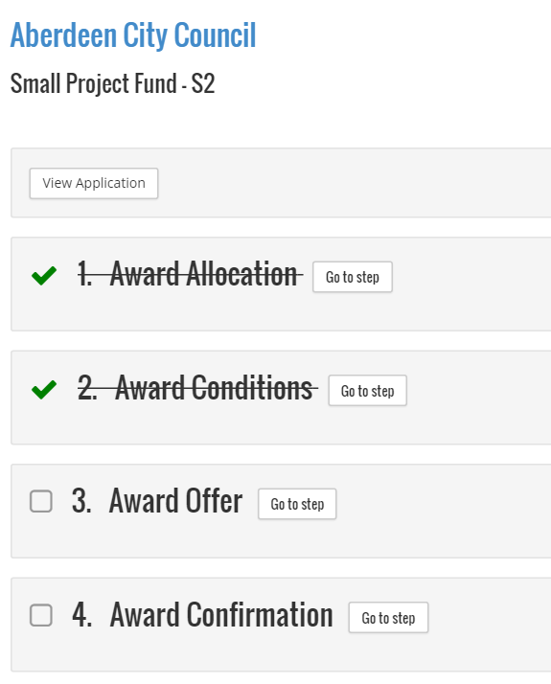
- Complete the required fields
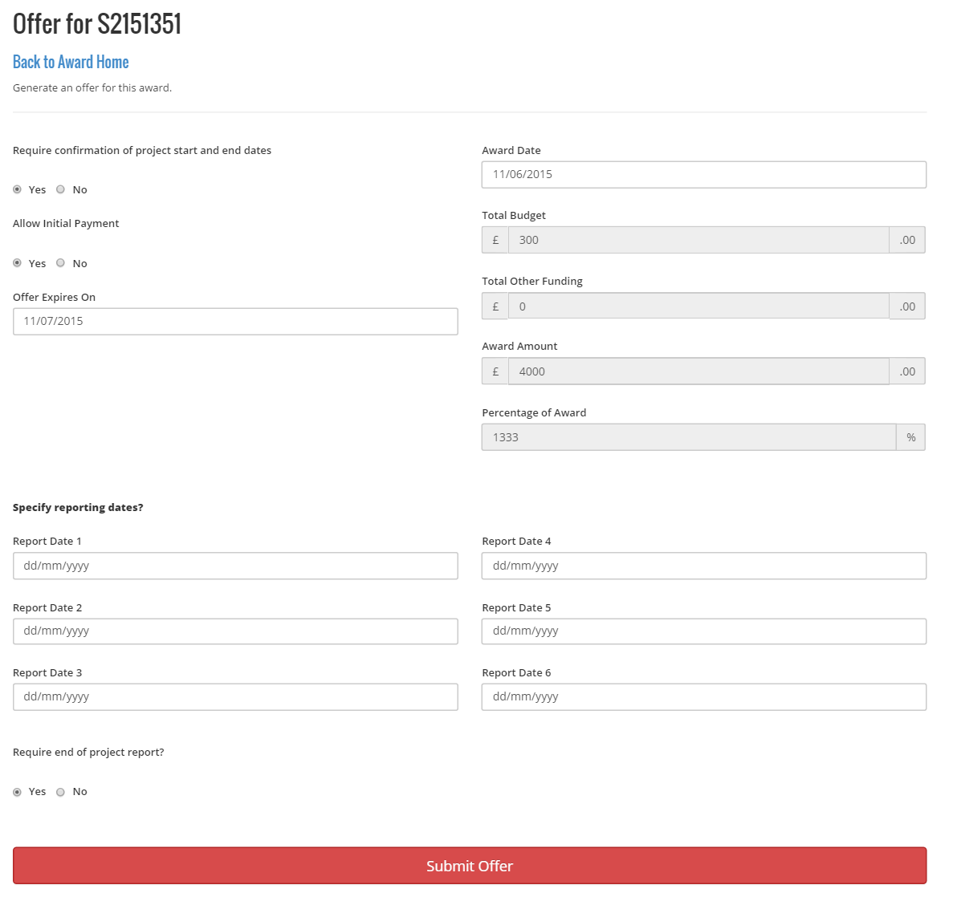
- Click Submit Offer
- Within Award Confirmation click Go To Step
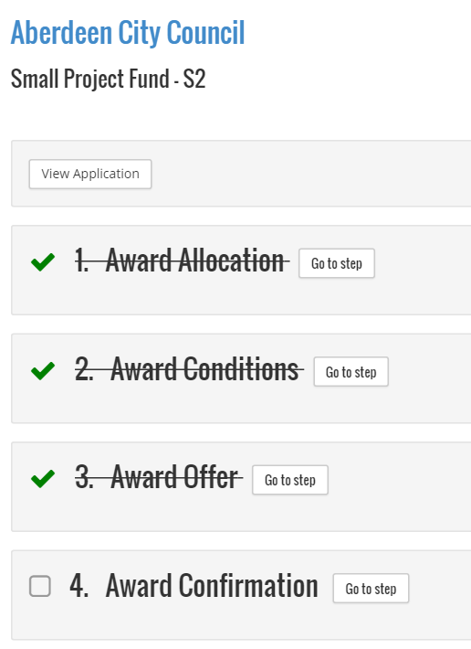
Note
The award offer will not be notified to the grant submitter until the results for the round are published.

Projects

Claims
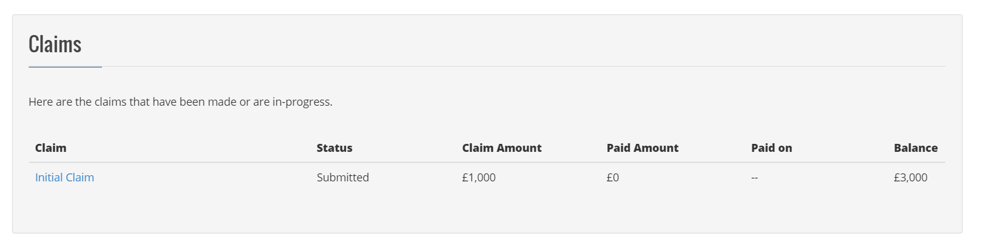

How to Run Claims Report for Sage Export
There are three main reports that Finance require to export and import into their Sage accounts package:-
- Finance Round Report
- Claims Report
- Slippage Report
The Claims Report is used to show all funds that have been claimed. There are three types of claim:-
- Initial Claim
Applicants can make an initial claim on the amount awarded. For an initial claim no proof of expenses is required.
- Interim Claim
Applicants can make interim claims on the amount awarded. Proof of expenses is required for interim claims
- Final Claim
Applicants can make a final claim. After the claim is processed and the project is shut down if there is balance left from the award that moves into splippage.
- Click on the Finance Menu and Select Claims
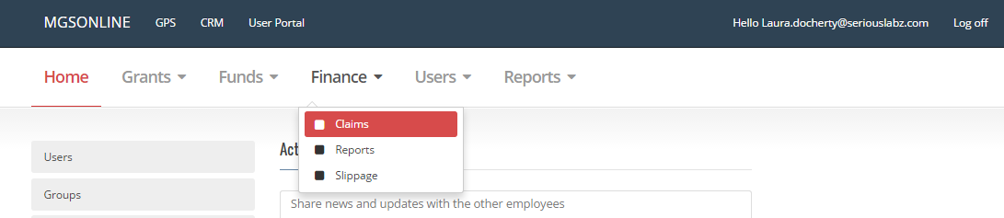
- Click on Pay Claims
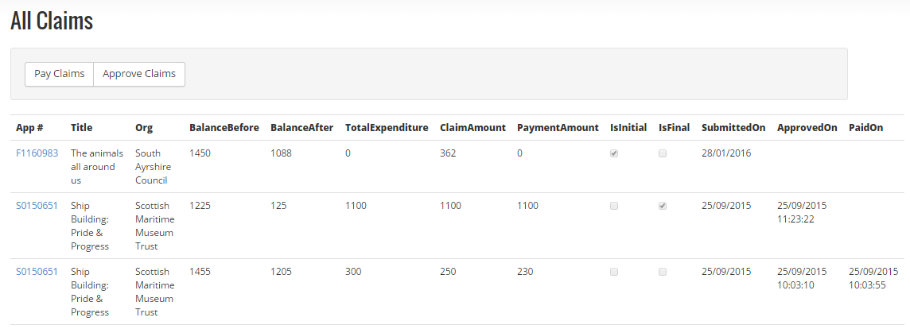
- Click Export Unpaid
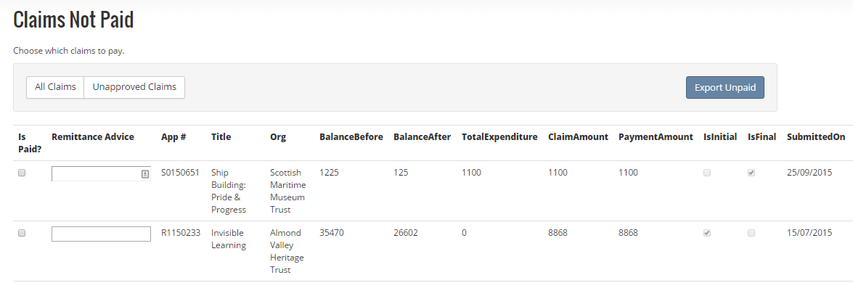

Project Reports

End of Project Reports

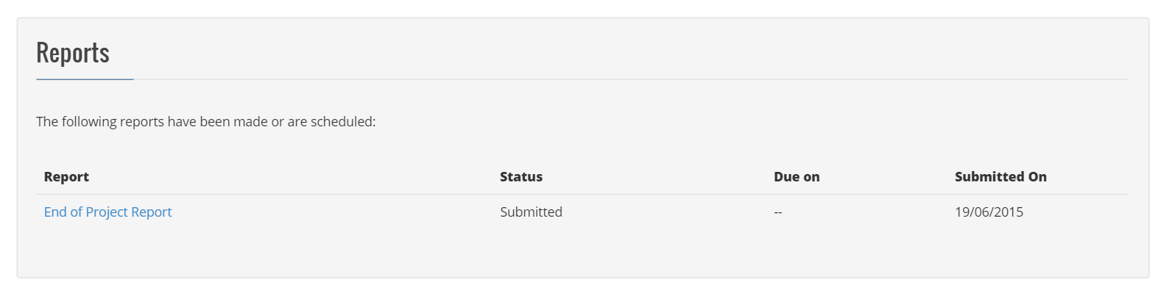

Organisations
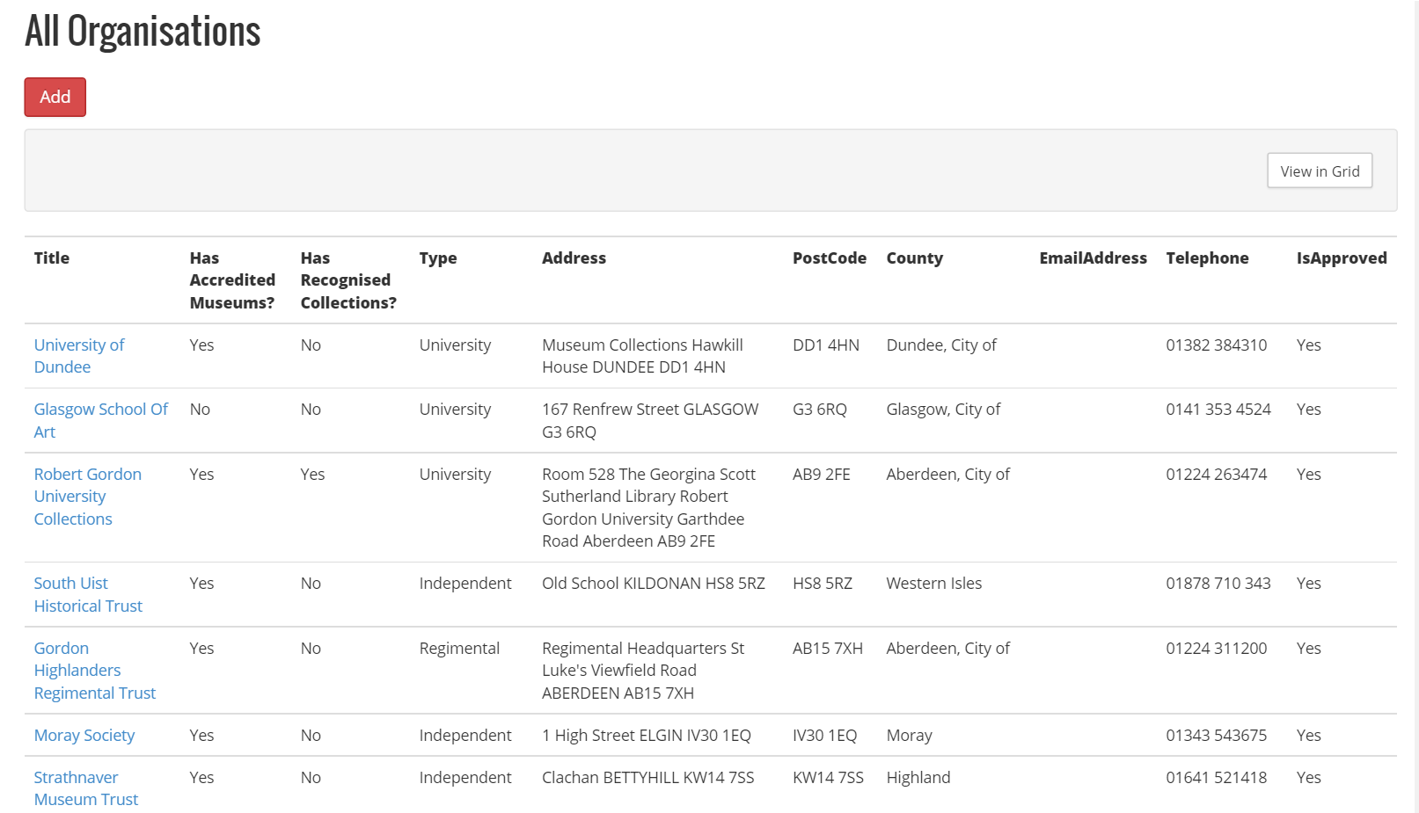

Understanding the All Organisation Dashboard
Within the all organisation dashboard there are a number of columns:
Title | Name of the organisation
Has Accredited Museums | Checkbox to demonstrate whether the organisation has accredited museums
Has Recognised Collections | Checkbox to demonstrate whether the organisation has accredited collections
Type | Type of organisation
Address | Address of the organisation
PostCode | Postcode of the organisation
Country | Country of the organisation
Email Address | Contact email address for the organisation
Telephone | Contact telephone number for the organisation
Is Approved | Status that is used by System Admin to allow an organisation to show in the list for end user selection

Creating a New Organisation
- Click Add on the all organisations dashboard
- Complete the relevant fields for the additional organisation
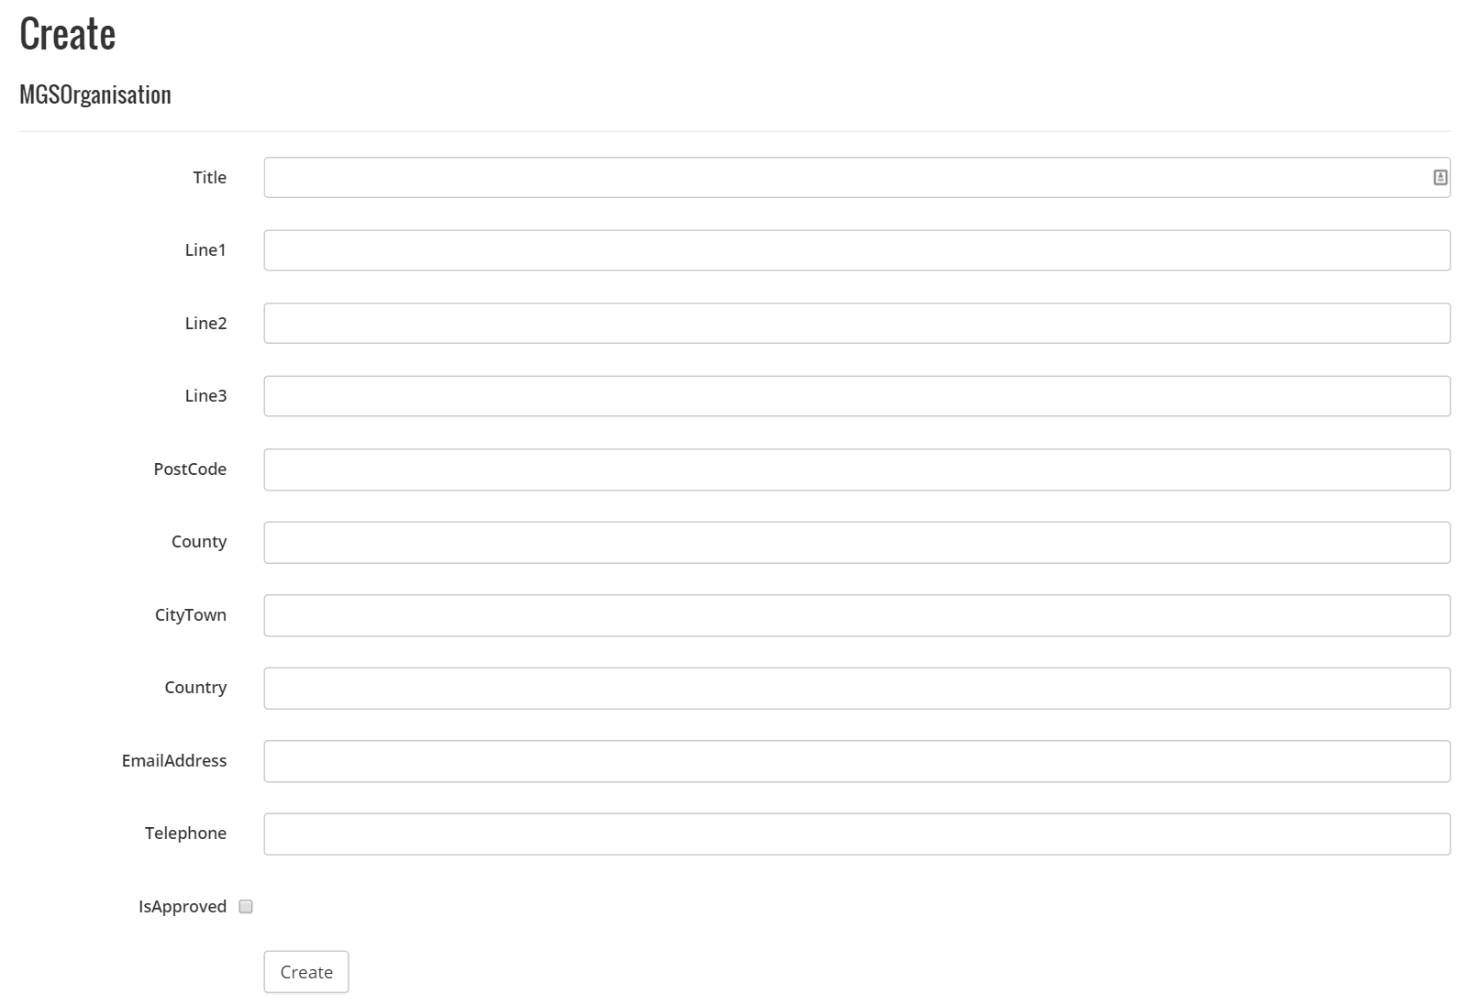
- Click Create

Edit an Existing Organisation
- Click on the title of the organisation
- Click Edit Org
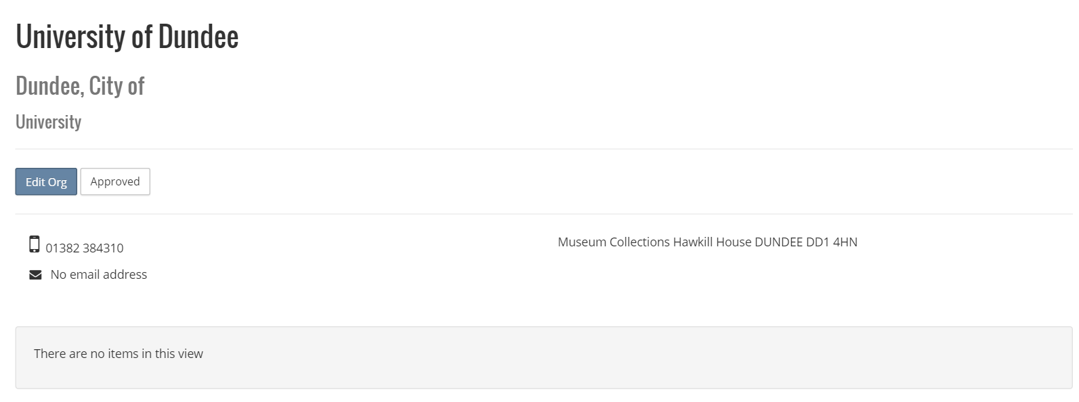
- Make amendments to the required fields
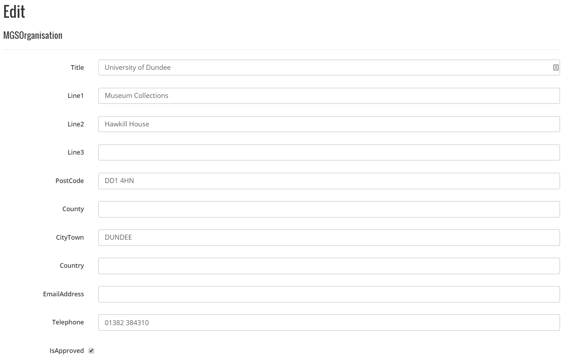
- Click Save

Museums
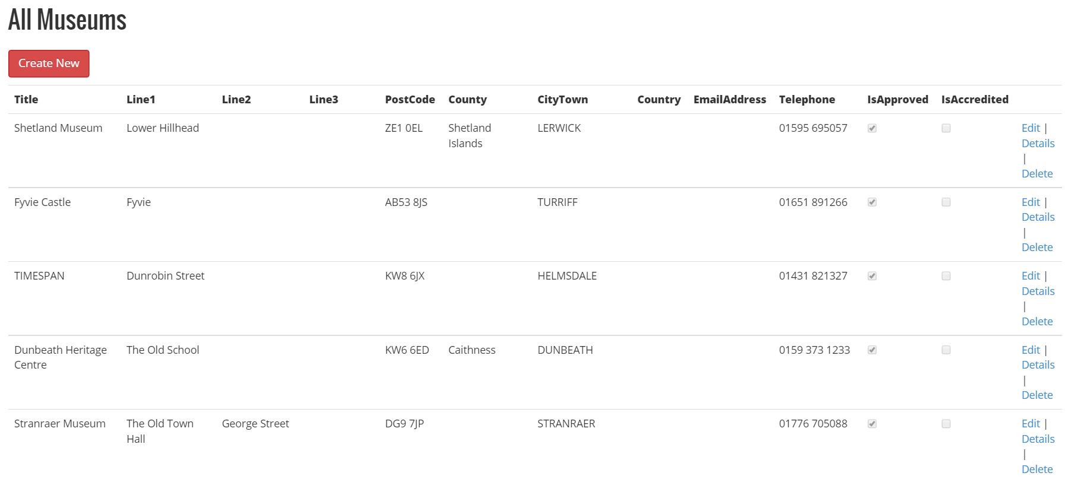

Understanding the All Museums Dashboard
Within the all museums dashboard there are a number of columns:
Title | Name of the Museum
Line1, Line2, Line3 | Address fields
PostCode | PostCode of the Museum
County | County of the Museum
CityTown | City or Town of the Museum
Country | Country of the Museum
Email Address | Email address of the museum
Is Approved | Status that is used by System Admin to allow a museum to show in the list for end user selection
Is Accredited | Status that is maintained by GPS Admin to show whether a museum is accredited

Creating a New Museum
- Click Create New on the All Museums Dashboard
- Complete the relevant fields for the additional museum
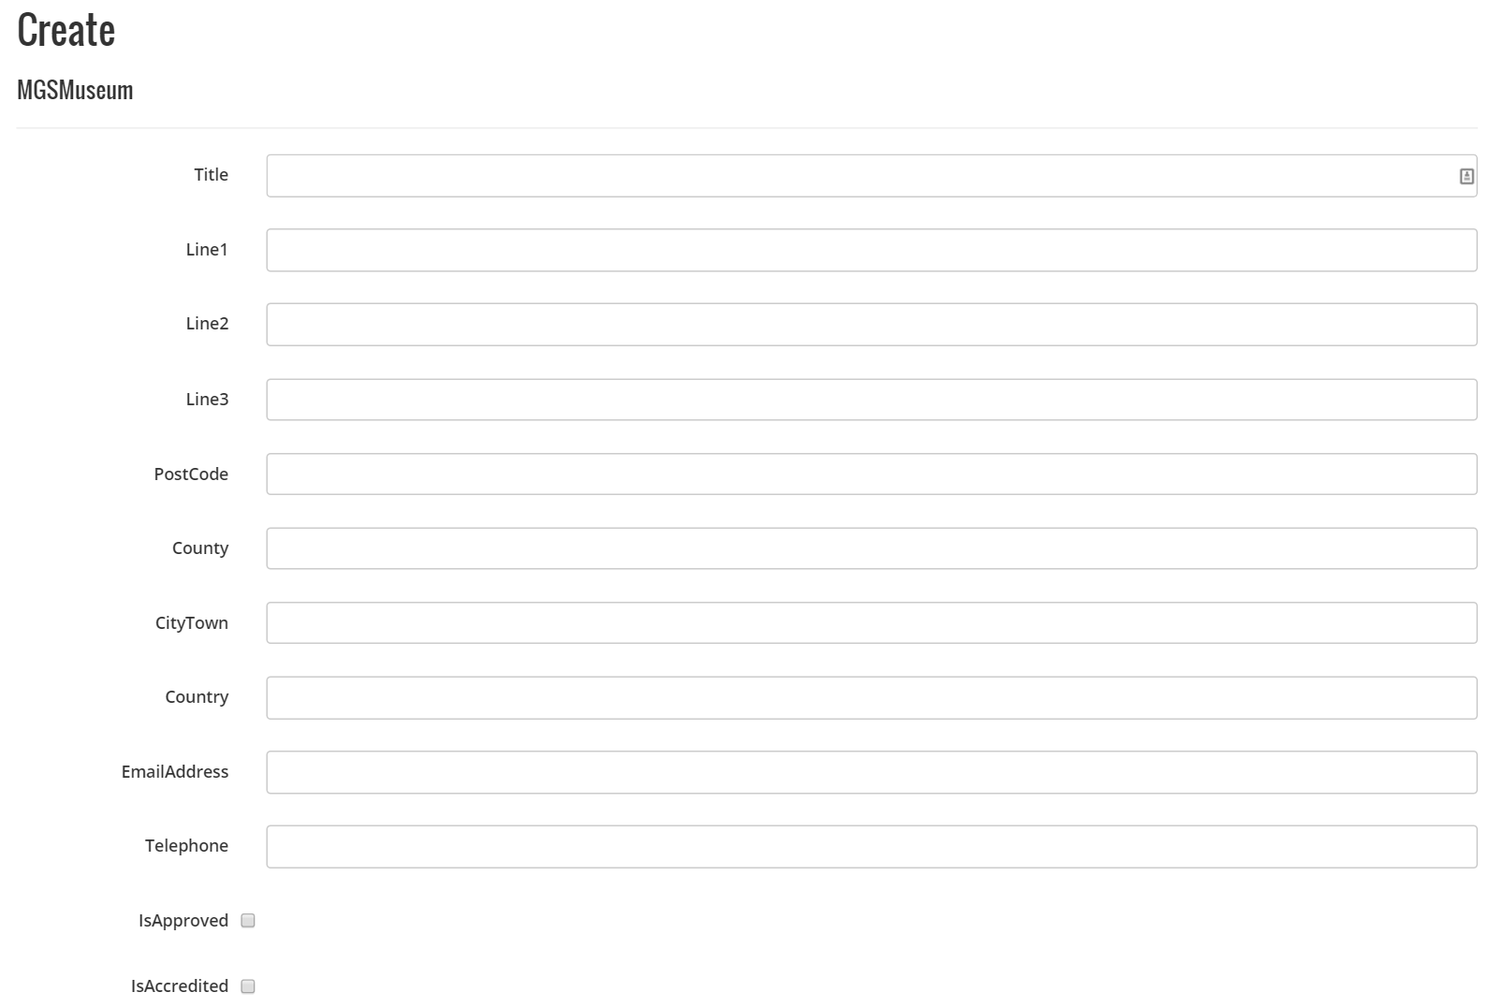
- Click Create

Edit an Existing Museum
- Click edit on the relevant Museum
- Make amendments to the required fields

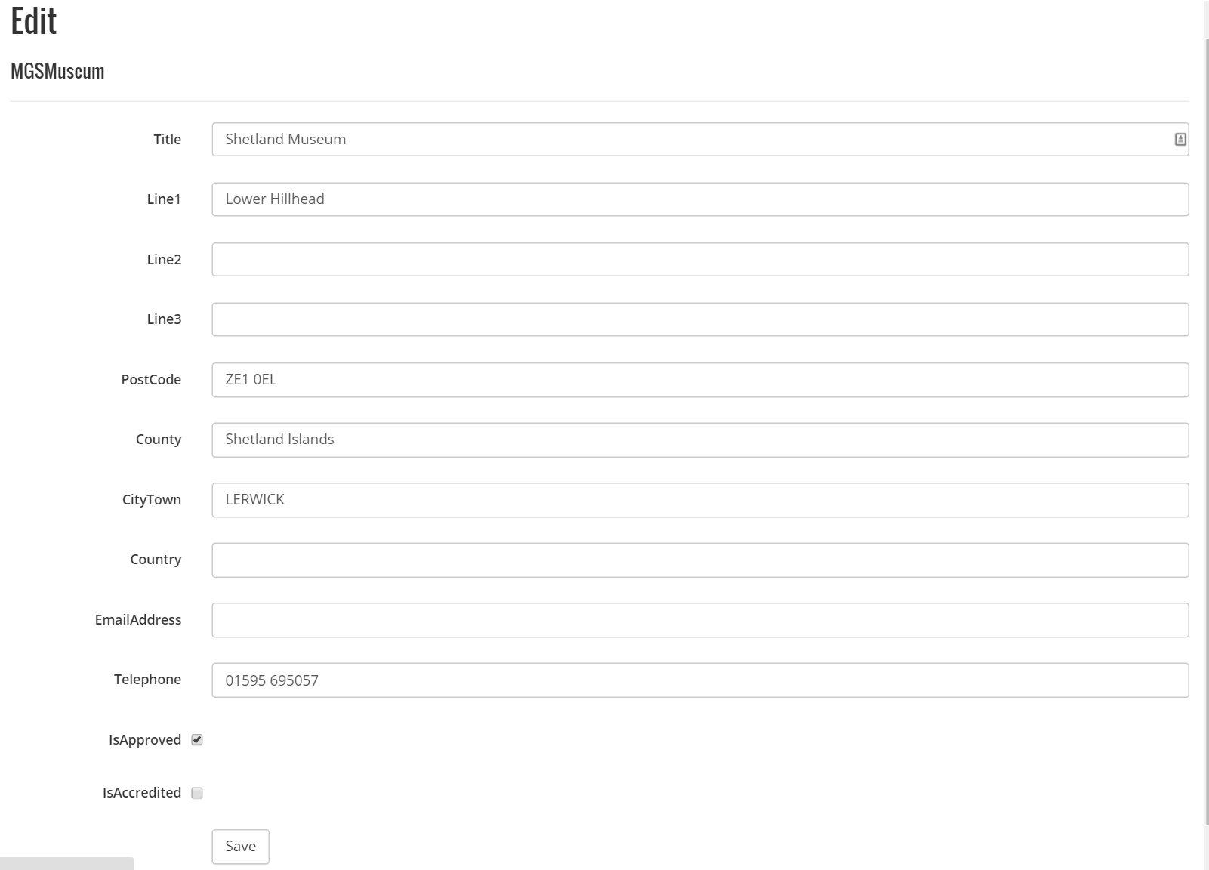

- Click Save

Delete an Existing Museum
- Click delete on the relevant Museum
- Check you have the correct Museum
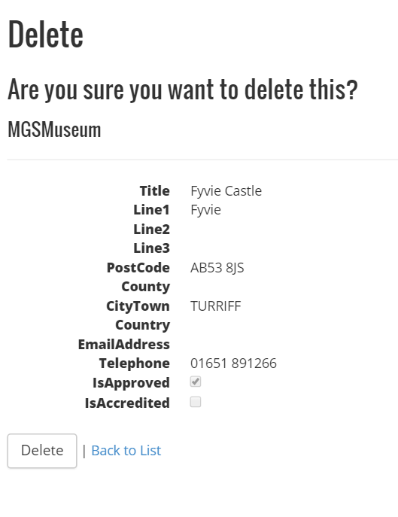
- Click Delete

Keywords
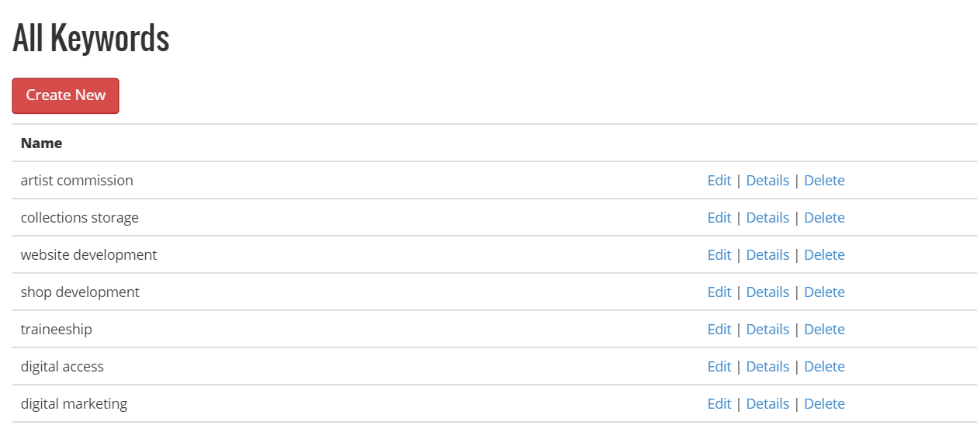

Understanding the Keywords Dashboard
Within the keywords dashboard the keywords that are currently in the system are displayed with options to Edit, View the Details and Delete.

Create a new Keyword
- Click on the Create New button in the Keywords Dashboard
- Input the name of your keyword
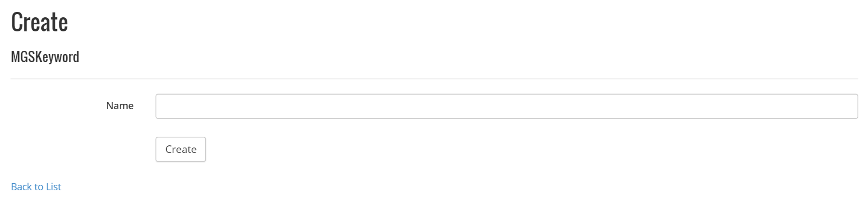
- Click Create

Edit a Keyword
- Click the word Edit opposite the keyword you require to amend
- Make the amendment
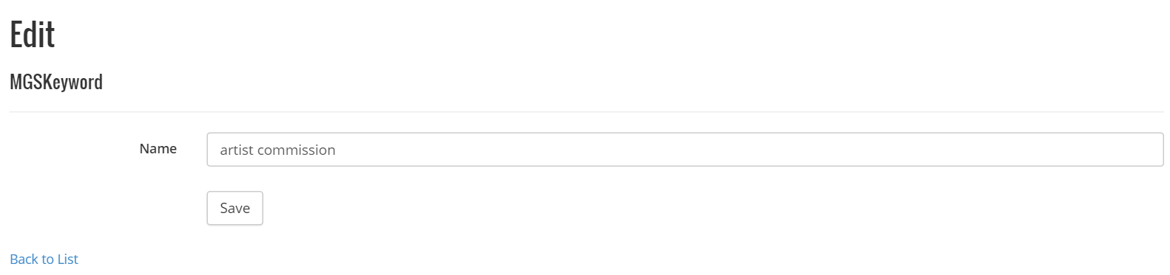
- Click Save

Delete a keyword
- Click the word Delete opposite the keyword you require to delete
- A confirmation box will appear to ensure you wish to delete the keyword. Check it is the correct keyword you wish to delete
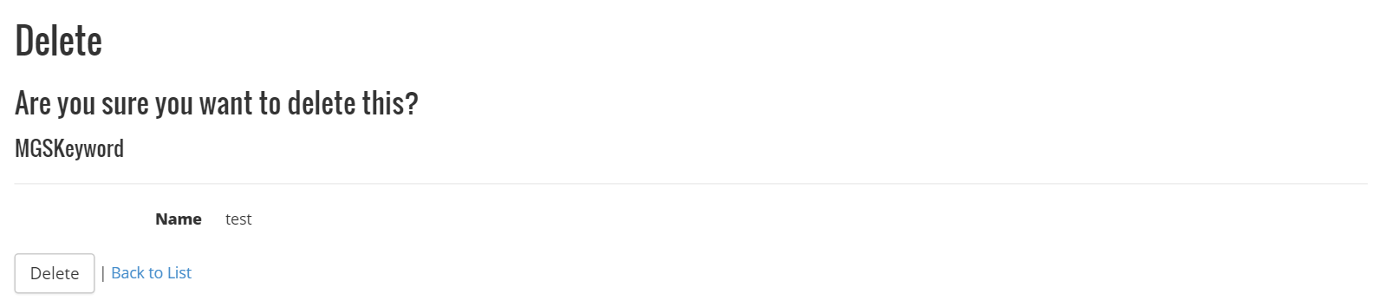
- Click Delete

Aims
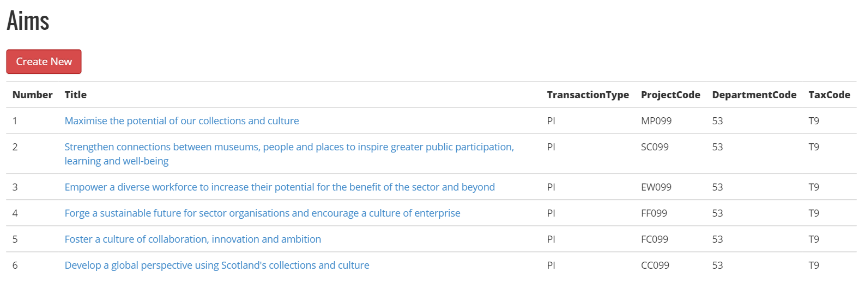

Understanding the Aims Dashboard
The Aims dashboard allows you to manage the aims from the National Strategy and allows you to create and manage National Strategy.
The Aims Dashboard is used specifically to map awards, claims and slippage to budget allocations.
Number | This is the number that relates to the aim
Title | The description of the aim
Transaction Type | The type of transaction that accounts department use to indicate a purchase invoice in the ledger. Typically this would be abbreviated PI for purchase invoice
Project Code | The project code maps the aim to the budget line item
Department Code | This is always 53 as specified by the accounts department
Tax Code | This is always T9 as specified by the accounts department

Creating a New Aim
- Click on Create New
- Complete the fields

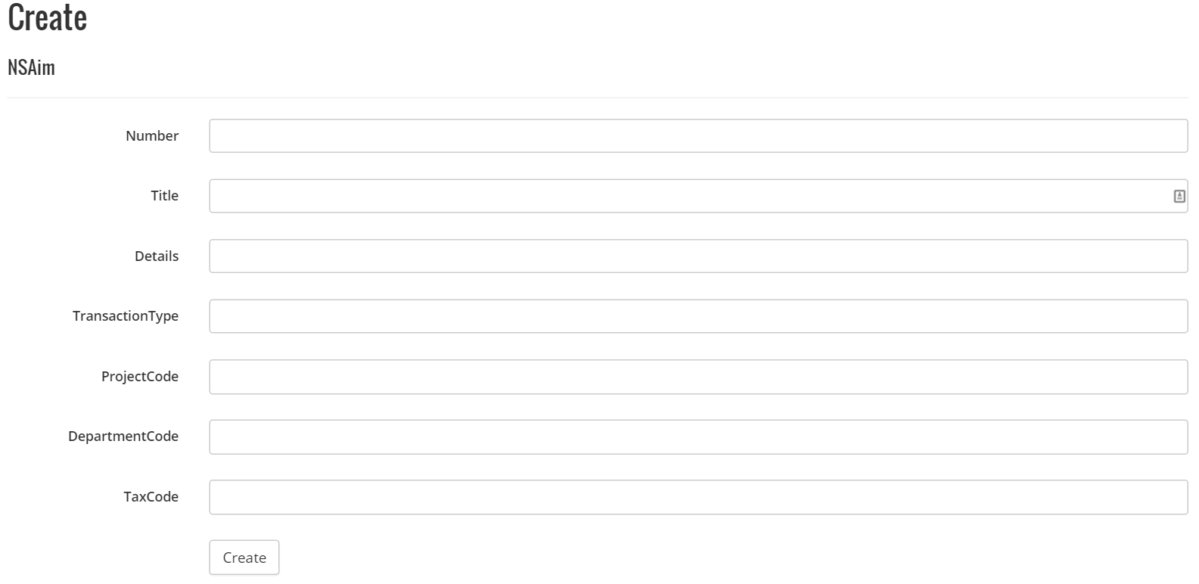
- Click Create

Edit an existing Aim
- Click on the relevant Aim

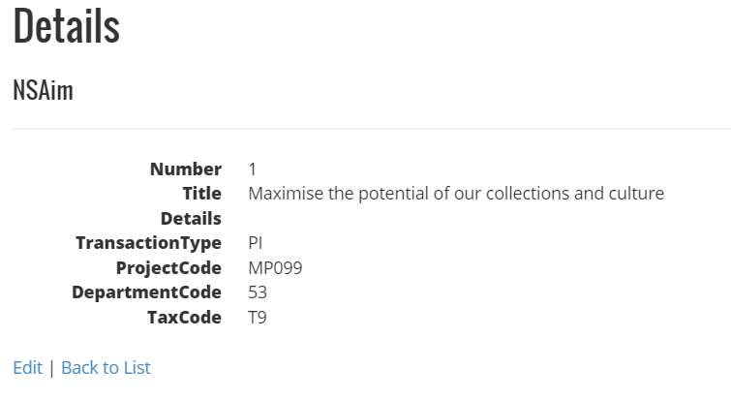
- Click Edit
- Make amendments to the required fields

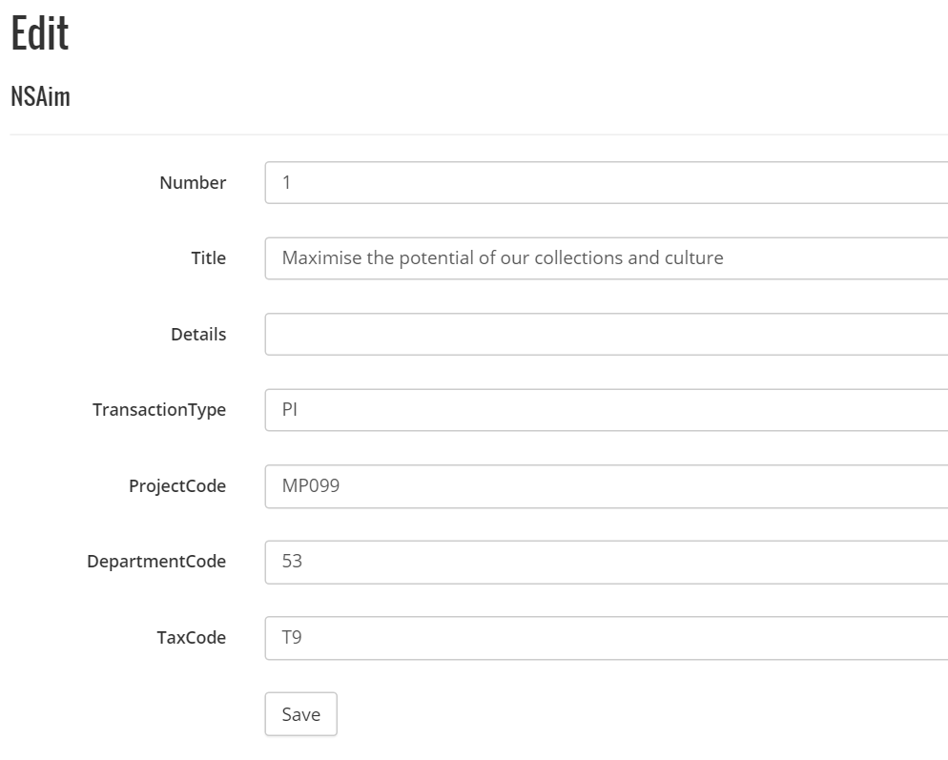

- Click Save

National Strategy
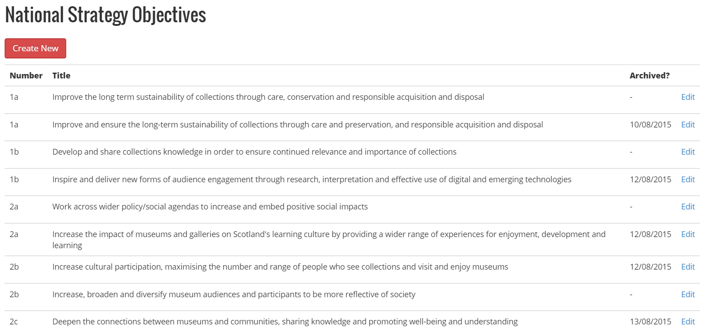

Understanding the National Strategy Dashboard
Within the National Strategy Dashboard there are a number of columns:
Number | This is the number that relates to MGS National Strategy Objectives
Title | The description of the objective
Archived? | This gives the facility to archive National Objectives that are no longer relevant. By archiving an objective it means that new grants no longer use that particular objective.

Creating a New National Strategy Objectives
- Click on Create New
- Complete the fields
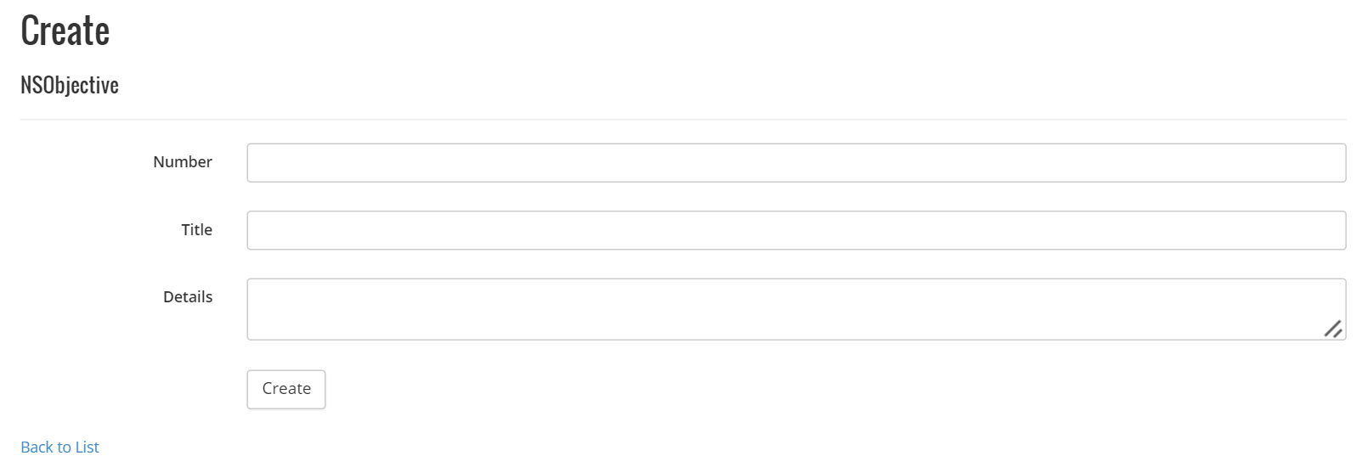
- Click Create

Edit an existing National Strategy Objectives
- Click edit on the relevant National Strategy Objective
- Make amendments to the required fields
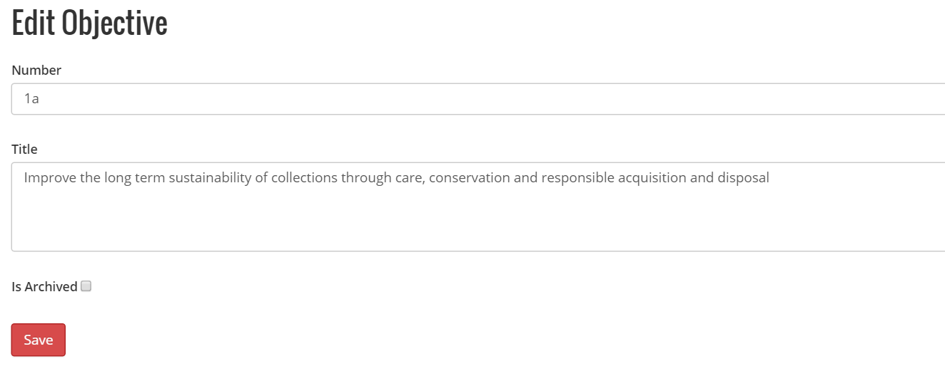
- Click Save

Archive an existing National Strategy Objectives

- Click edit on the relevant National Strategy Objective
- Click the Is Archived check box
- Click Save

Recognition
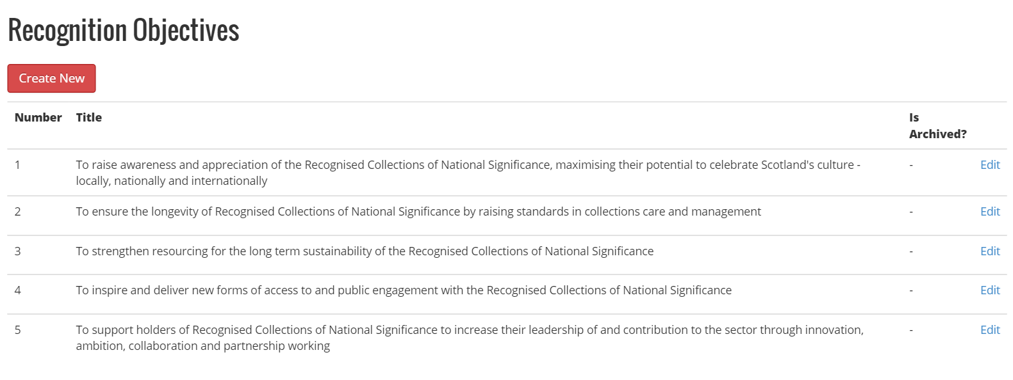

Understanding the Recognition Objectives Dashboard
The Recognition Objectives Dashboard is where all the recognition objectives are held.
Number | This is the number that relates to the Recognition Objective
Title | The description of the objective
Archived? | This gives the facility to archive Recognition Objectives that are no longer relevant. By archiving an objective it means that new grants no longer use that particular objective.

Creating a New Recognition Objective
- Click on Create New from the Recognition Objective Dashboard
- Complete the Number, Title and Details fields
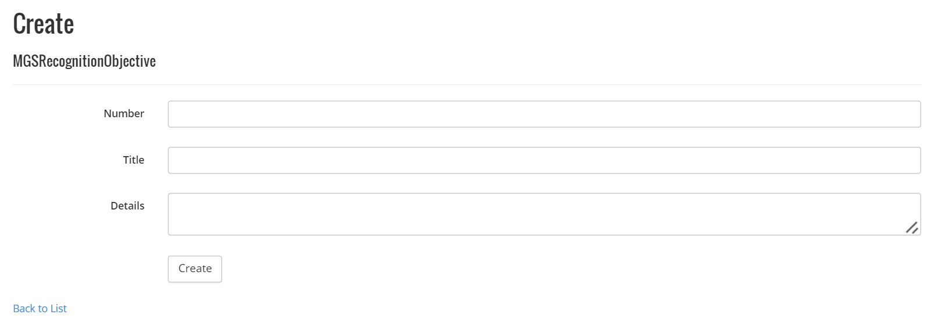
- Click Create

Edit an Existing Recognition Objective
- Click edit on the relevant recognition objective
- Make amendments on the required fields
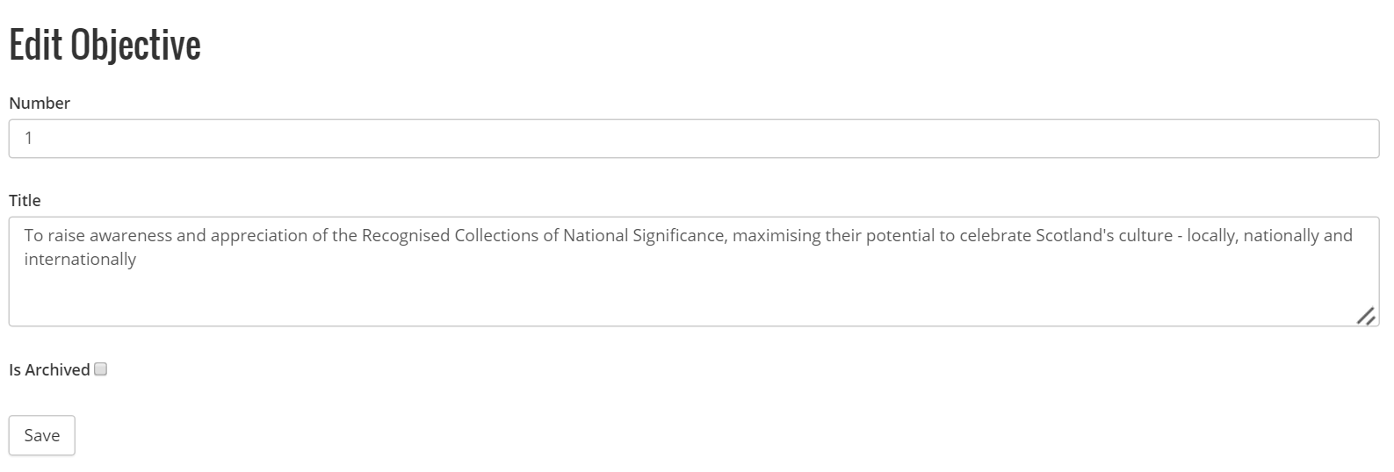

- Click Save

Archive an existing Recognition Objectives

- Click edit on the relevant Recognition Objective
- Click the Is Archived check box
- Click Save

Slippage
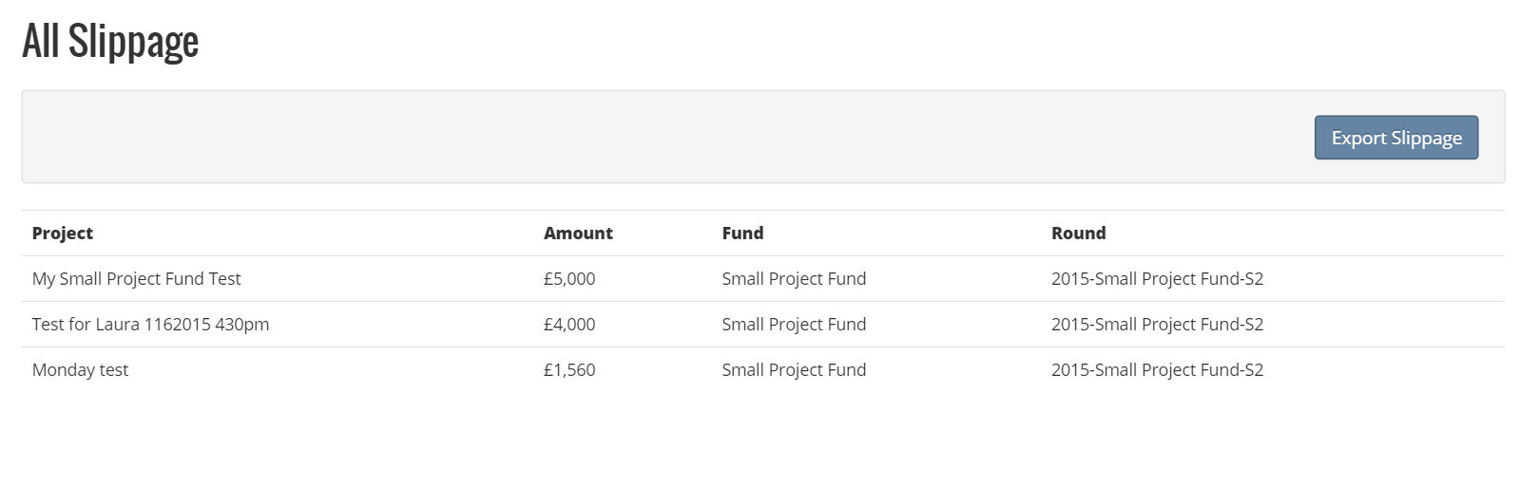
The All Slippage Dashboard is where grants projects that have been finalised and closed but haven’t claimed all the money will present.
The Export Slippage button allows the slippage details to be exported to excel for passing to Finance.

Understanding the System Flow

Account Creation
Create A Fund

Create A Funding Round

Starting the Assessment Process

Starting the Award Process

